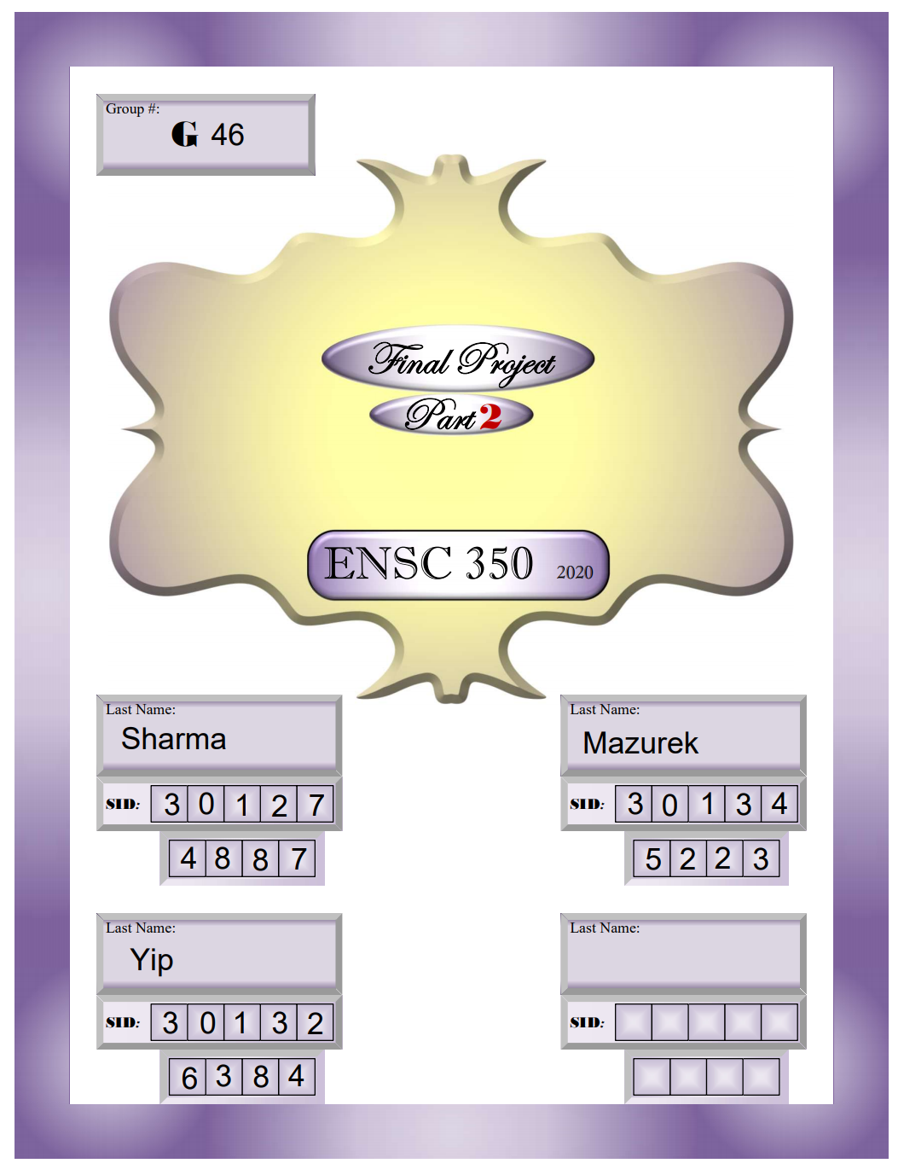

**Design Entities** **3**

Adder Entity 3

ArithUnit Entity 4

LogicUnit Entity 5

SLL64 Entity 6

SRL64 Entity 7

SRA64 Entity 8

ShiftUnit Entity 9

ExecUnit Entity 10

**Simulations** **11**

Logic Unit -- Functional Waves 11

Logic Unit -- Timing Waves 13

Arithmetic Unit -- Functional Waves 15

Arithmetic Unit -- Timing Waves 17

Shift Unit -- Functional Waves 19

SLL32 19

SLL64 20

SRL32 21

SRL64 22

SRA32 23

SRA64 24

Shift Unit -- Timing Waves 25

SLL32 25

SLL64 26

SRL32 27

SRL64 28

SRA32 29

SRA64 30

Execution Unit -- Functional Waves 31

Execution Unit -- Timing Waves 32

**Synthesis and Fitting** **33**

**Conclusion** **38**

# 

# 

# Design Entities

## **Adder Entity**

entity Adder is

generic (N : natural := 64);

port (A, B : in std_logic_vector(N-1 downto 0);

Y : out std_logic_vector(N-1 downto 0);

Cin : in std_logic;

Cout, Ovfl : out std_logic);

end entity Adder;

In this entity, we are implementing a ripple adder, which can add or subtract two 64 bit numbers. The ripple adder is constructed using Full Adders, which connects the carry out of the first Full Adder into the carry input of the second Full Adder. This implementation uses 64 Full adders, and the final carry out, C64, is our carry out which is used in the Arithmetic Unit down the line. The overflow, which is used in the arithmetic unit, is calculated in the adder as well. The output of the Adder is a 64 bit vector called Y, which is the output that is fed to the Arithmetic Unit.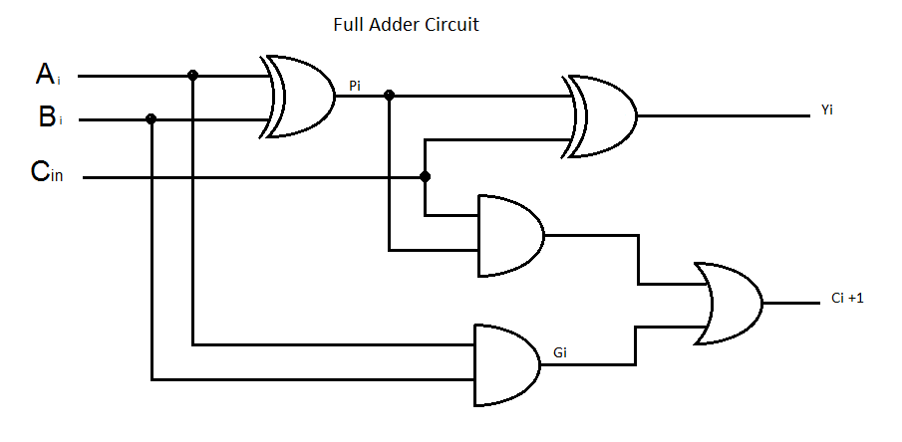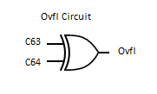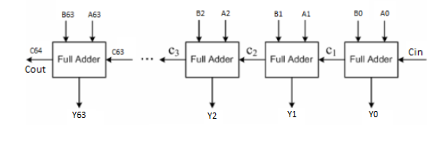

## ArithUnit Entity

entity ArithUnit is

generic (N : natural := 64);

port (

A, B : in std_logic_vector(N-1 downto 0);

Y : out std_logic_vector(N-1 downto 0);

NotA, AddnSub, ExtWord : in std_logic;

Cout, Ovfl, Zero, AltB, AltBu : out std_logic);

end entity ArithUnit;

In the ArithUnit Entity, we have inputs A and B, which are 64 bit inputs, which are passed into the adder, either inverted or non-inverted. We also have inputs NotA, AddnSub, and ExtWord, which all control multiplexers to manipulate the data to either add or subtract, and to sign extend the data that we are working with. For our outputs we have Y, which is a 64 bit number, that is the final product that comes out from the ArithUnit after all the data manipulations. The Zero status signal indicates whether or not the result is 0. Also, we have Cout and Ovfl, which are calculated as part of the Adder entity and used as status signals in the AritUnit. Lastly, we have A less than B, AltB, and A less than B Unsigned, AltBu, that are both calculated using Cout and Ovfl.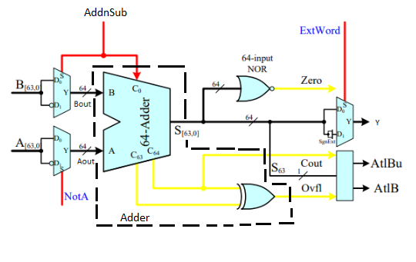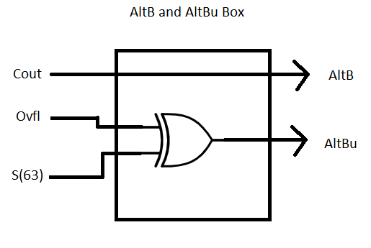

## LogicUnit Entity

entity LogicUnit is

generic (N : natural := 64);

port (A,B : in std_logic_vector(N-1 downto 0);

LogicFN : in std_logic_vector(1 downto 0);

Y : out std_logic_vector(N-1 downto 0));

end entity LogicUnit;

Description:

In the LogicUnit Entity, we have two 64 bit number inputs, A and B, that are sent through a 4-input to 1-output multiplexer, which is controlled by a two bit vector called LogicFN. In the case where LogicFN is “00”, B gets passed through the multiplexer. In the case LogicFN is “01”, A is exclusive or’d with B, when LogicFN is “10”, A and B are or’d together and passed through. Finally, when LogicFN is “11”, A and B are logically and’d together, and produced at the output of the multiplexer. The output Y is a 64 bit logic vector which is connected to the output of the multiplexer, and is the only output of the LogicUnit.

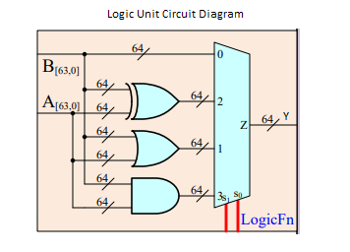

## SLL64 Entity

Entity SLL64 is -- Shift Left Logical

Generic ( N : natural := 64 );

Port ( X : in std_logic_vector( N-1 downto 0 );

Y : out std_logic_vector( N-1 downto 0 );

ShiftCount : in unsigned( integer(ceil(log2(real(N))))-1 downto 0 ) );

End Entity SLL64;

Description:

In the following entity, the input X is shifted to the left logically by anywhere between 0 to 63 bits. The first multiplexer in the barrel shifter can shift the bits by either 16, 32, or 48 bits depending on what the fourth and fifth bits of ShiftCount are set to. The second multiplexer is shifting the bits by either 4, 8, or 12 bits depending on what the third or second bits are for the ShiftCount. The third multiplexer in the barrel shifter is shifting the bits by either 1, 2, or 3 bits to the left depending on the zeroth and first bit of ShiftCount. The combination of these three multiplexers can shift the original input by any number of bits between 0 and 63. The leftmost bit is discarded and the rightmost bit is filled with a zero, to fill the empty spot.

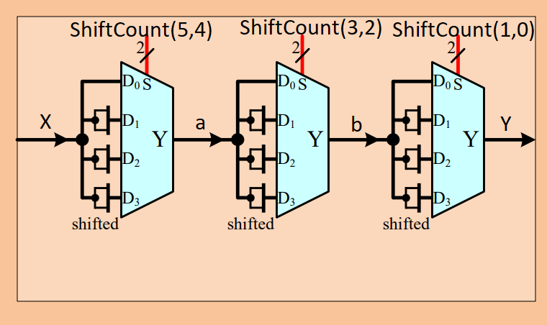

## SRL64 Entity

Entity SRL64 is -- Shift Right Logical

Generic ( N : natural := 64 );

Port ( X : in std_logic_vector( N-1 downto 0 );

Y : out std_logic_vector( N-1 downto 0 );

ShiftCount : in unsigned( integer(ceil(log2(real(N))))-1 downto 0 ) );

End Entity SRL64;

Description:

In the following entity, the input X is shifted to the right logically by anywhere between 0 to 63 bits. The first multiplexer in the barrel shifter can shift the bits by either 16, 32, or 48 bits depending on what the fourth and fifth bits of ShiftCount are set to. The second multiplexer is shifting the bits by either 4, 8, or 12 bits depending on what the third or second bits are for the ShiftCount. The third multiplexer in the barrel shifter is shifting the bits by either 1, 2, or 3 bits to the right depending on the zeroth and first bit of ShiftCount. The combination of these three multiplexers can shift the original input by any number of bits between 0 and 63. The rightmost bit is discarded and the leftmost bit is filled with a zero, to fill the empty spot.



## SRA64 Entity

Entity SRA64 is -- Shift Right Logical

Generic ( N : natural := 64 );

Port ( X : in std_logic_vector( N-1 downto 0 );

Y : out std_logic_vector( N-1 downto 0 );

ShiftCount : in unsigned( integer(ceil(log2(real(N))))-1 downto 0 ) );

End Entity SRA64;

Description:

In the following entity, the input X is shifted to the right logically by anywhere between 0 to 63 bits. The first multiplexer in the barrel shifter can shift the bits by either 16, 32, or 48 bits depending on what the fourth and fifth bits of ShiftCount are set to. The second multiplexer is shifting the bits by either 4, 8, or 12 bits depending on what the third or second bits are for the ShiftCount. The third multiplexer in the barrel shifter is shifting the bits by either 1, 2, or 3 bits to the right depending on the zeroth and first bit of ShiftCount. The combination of these three multiplexers can shift the original input by any number of bits between 0 and 63. The rightmost bit is fed into the empty spot in the leftmost spot of the 64 bit number.



## ShiftUnit Entity

Entity ShiftUnit is

Generic ( N : natural := 64 );

Port ( A, B, C : in std_logic_vector( N-1 downto 0 );

Y : out std_logic_vector( N-1 downto 0 );

ShiftFN : in std_logic_vector( 1 downto 0 );

ExtWord : in std_logic );

End Entity ShiftUnit;

Description:

The ShiftUnit entity includes three 64 bit number inputs, A, B and C. The inputs will be sent through 5 2-channel multiplexers, which are controlled by a 2 bit vector called ShiftFN and another 1 bit vector called ExtWord. When ExtWord is “0”, the outputs controlled by ExtWord are not sign extended, while they will be sign extended when ExtWord is “1”. For ShiftFN to be “00”, the input C will be passed directly to the output Y. When ShiftFN is “01”, A is shifted to the left logically, that is, the bits of A will be moved to the left. When ShiftFN is “10”, A is shifted to the right logically. When ShiftFN is “11”, A is shifted to the right arithmetically. The input B is used for

The shift count. The output Y is a 64 bit logic vector, which is the result after the input A has been executed the shifting operations.

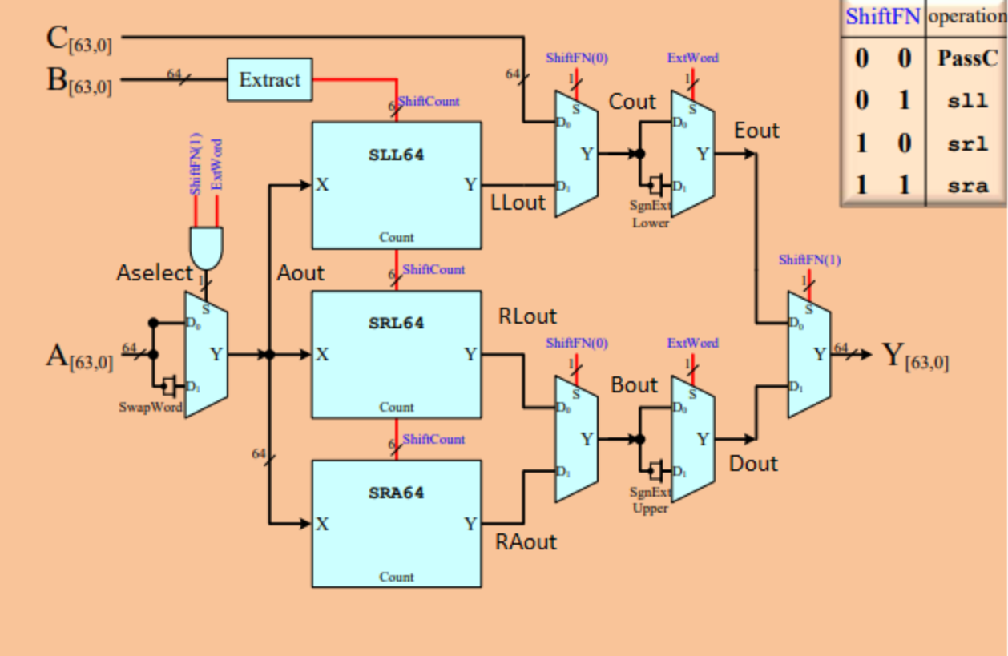

## ExecUnit Entity

Entity ExecUnit is

Generic ( N : natural := 64 );

Port ( A, B : in std_logic_vector( N-1 downto 0 );

NotA : in std_logic := '0';

FuncClass, LogicFN, ShiftFN : in std_logic_vector( 1 downto 0 );

AddnSub, ExtWord : in std_logic := '0';

Y : out std_logic_vector( N-1 downto 0 );

Zero, AltB, AltBu : out std_logic );

End Entity ExecUnit;

Description:

The ExecUnit Entity has two 64 bit number inputs, A and B. This unit is simply the combination of 3 entities from the above sections. The upper part is actually the Arithmetic Unit, and the middle part is the Shift Unit. However, the input C from the Shift Unit is replaced with another intermediate signal called S which is a 64 bit number signal and also the outputs of the 64-adder. By making a copy of the inputs A and B, the bottom part is the Logic Unit. Therefore, the whole ExecUnit Entity will be controlled by FuncClass, ShiftFN, ExtWord and LogicFn.

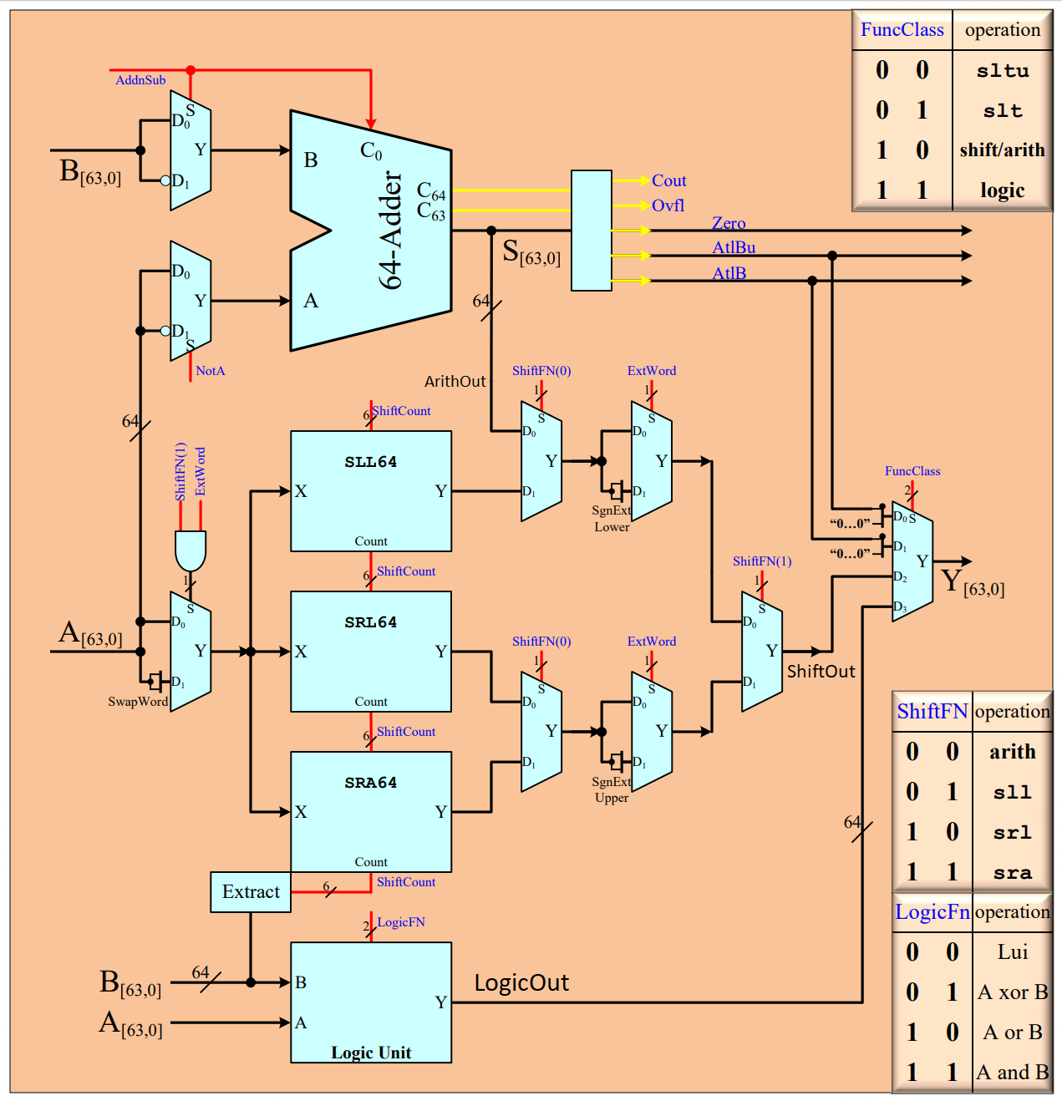

# Simulations

## Logic Unit -- Functional Waves

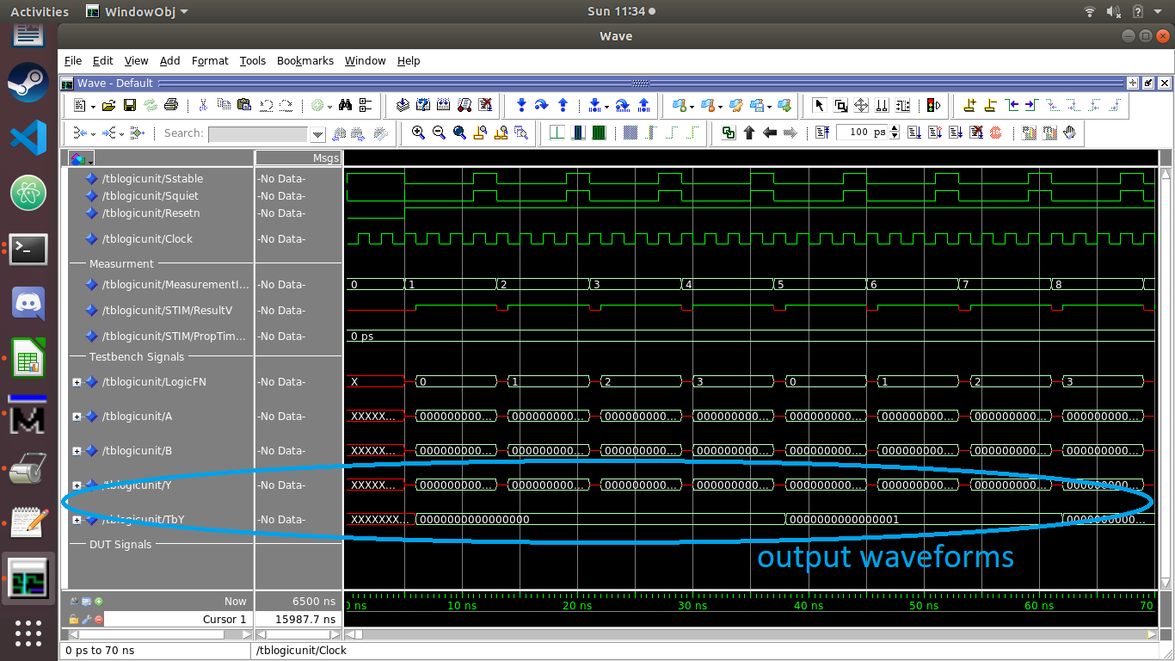

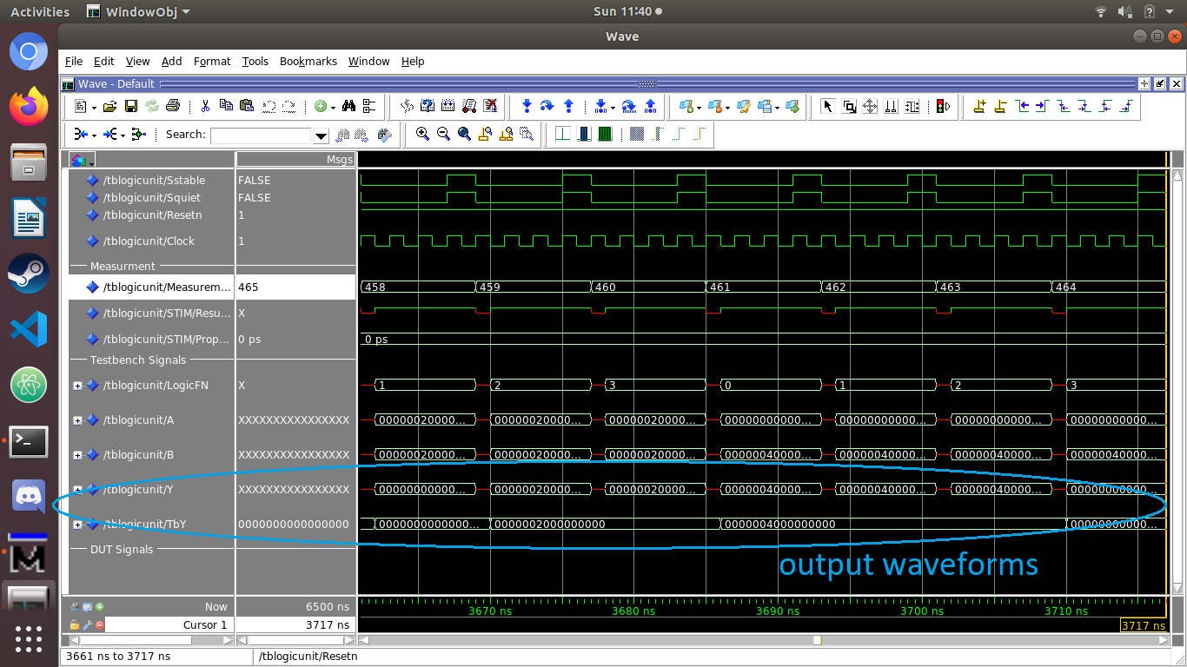

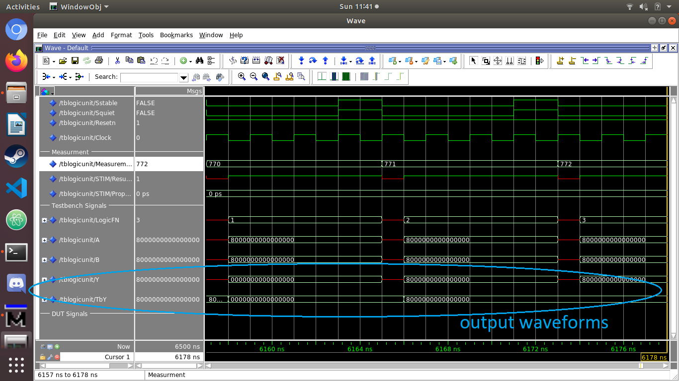

The waveforms circled are the output waveforms, Y and TbY, in the testbench signals section. Y is the experimental output, and TbY is the theoretical output. Ideally, when they are the same, ResultV signal is set to 1, indicating a pass for the measurement, else, it is set to 0, indicating a fail. No output is generated for the first clock rising edge at the start of each measurement. The signal LogicFN dictates which logic operation is being evaluated, 01 for XOR, 10 for OR, 11 for AND.

## Logic Unit -- Timing Waves

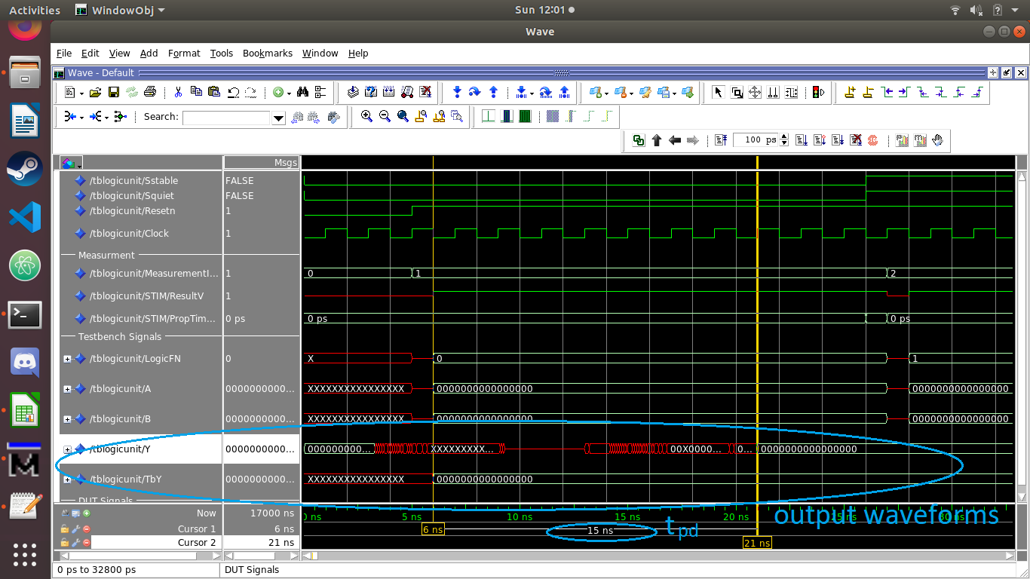

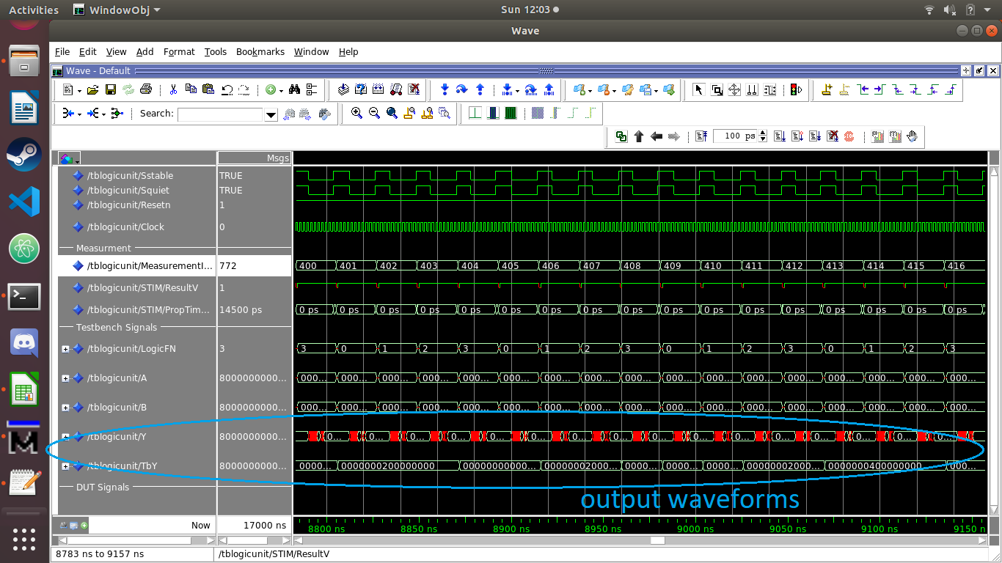

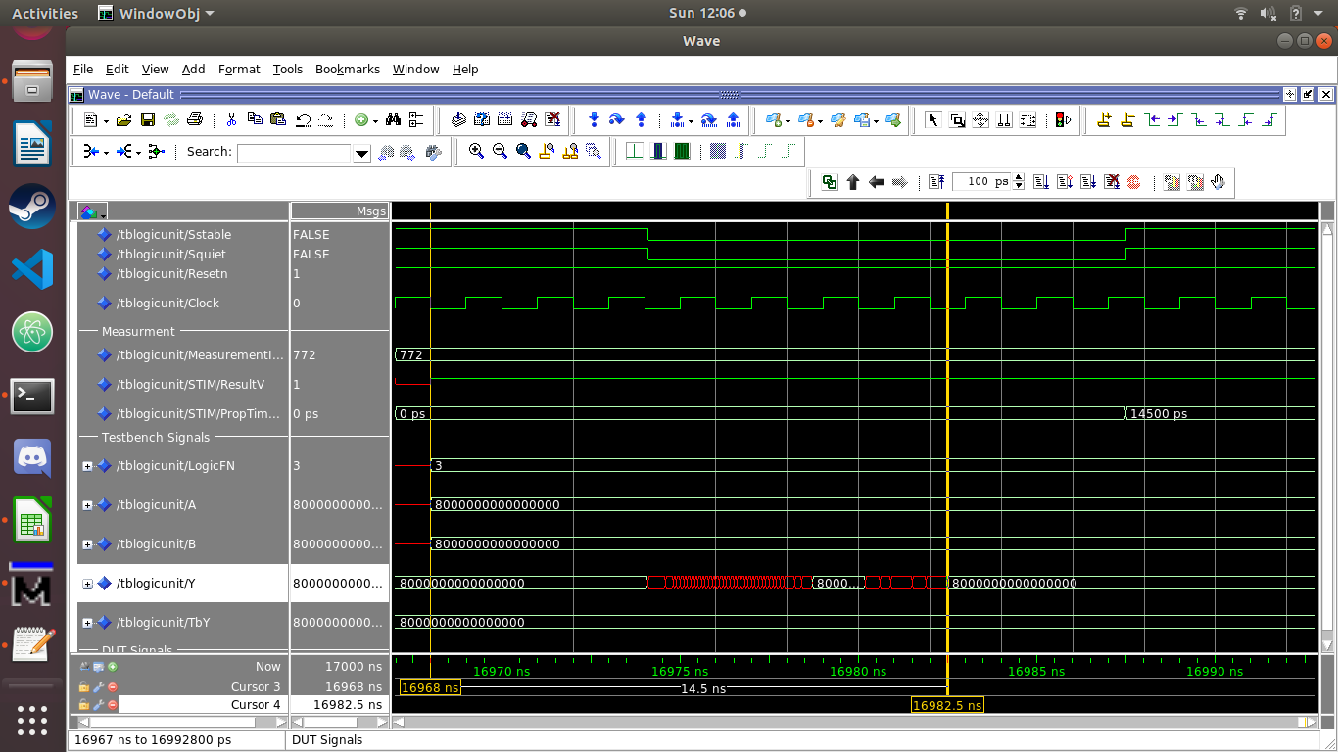

Cursors are placed in these screenshots to show the propagation delay tpd. The cursors are placed at the start of each input signal and at the point in time where the output Y is stable. The propagation delays are sampled at 14.5 and 15 ns and remain consistently near those values for all measurements. The signal STIM/PropTimeDelay shows the estimated propagation delay for each measurement according to intel’s specifications for the Cyclone IV FPGA. For example, the estimated delay for measurement 772 (14.5 ns) matches the delay measured by the cursors above.

## Arithmetic Unit -- Functional Waves

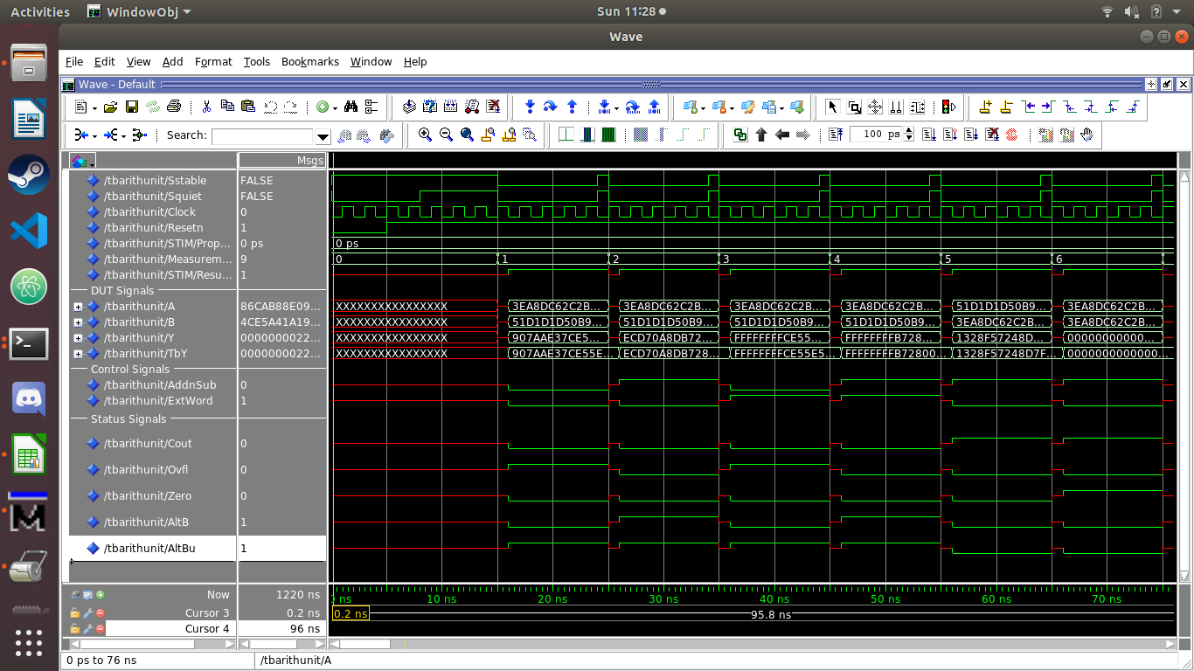

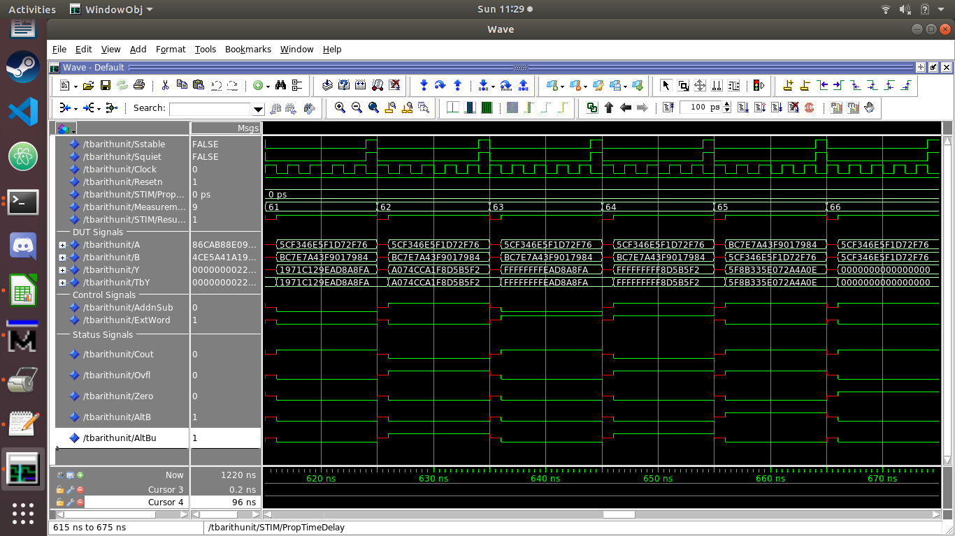

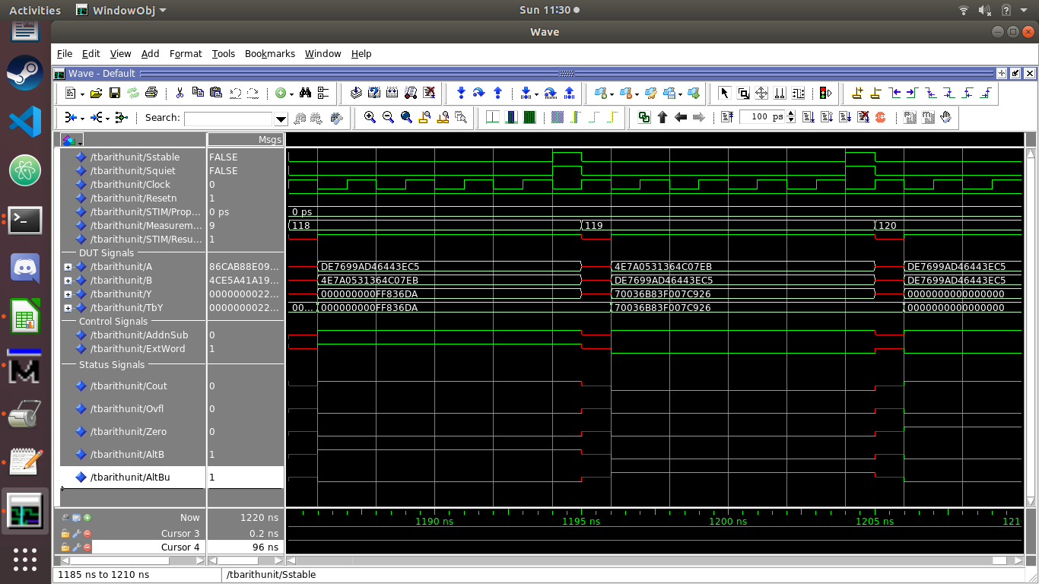

The results of the functional simulation of the arithmetic unit are shown above. Both 32-bit and 64-bit [ExtWord = 1 and 0 respectively], and addition and subtraction [AddnSub = 0 and 1 respectively] are being tested. The test passes if ResultV = 1 at the end of each measurement. The status signals are also tested against the test vectors, to ascertain the correct status flags are being set based on the design entity specifications. Incorrect status signals will cause ResultV to be set to 0, indicating a failed test case. In this case, ResultV is never 0, indicating all cases pass.

## Arithmetic Unit -- Timing Waves

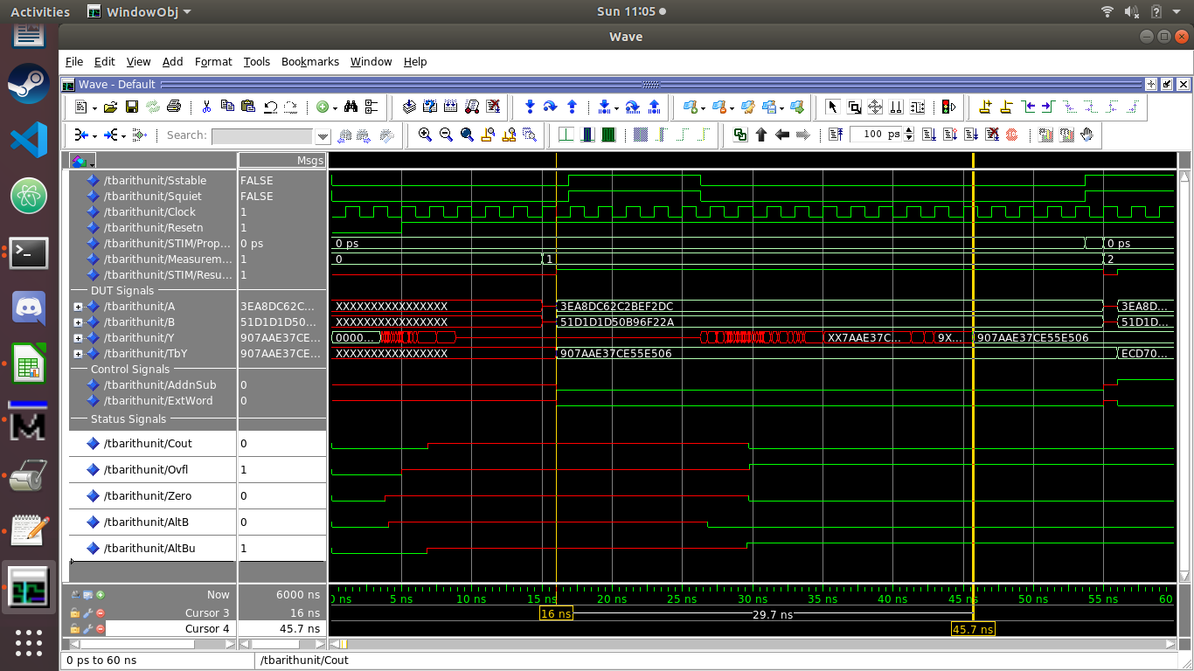

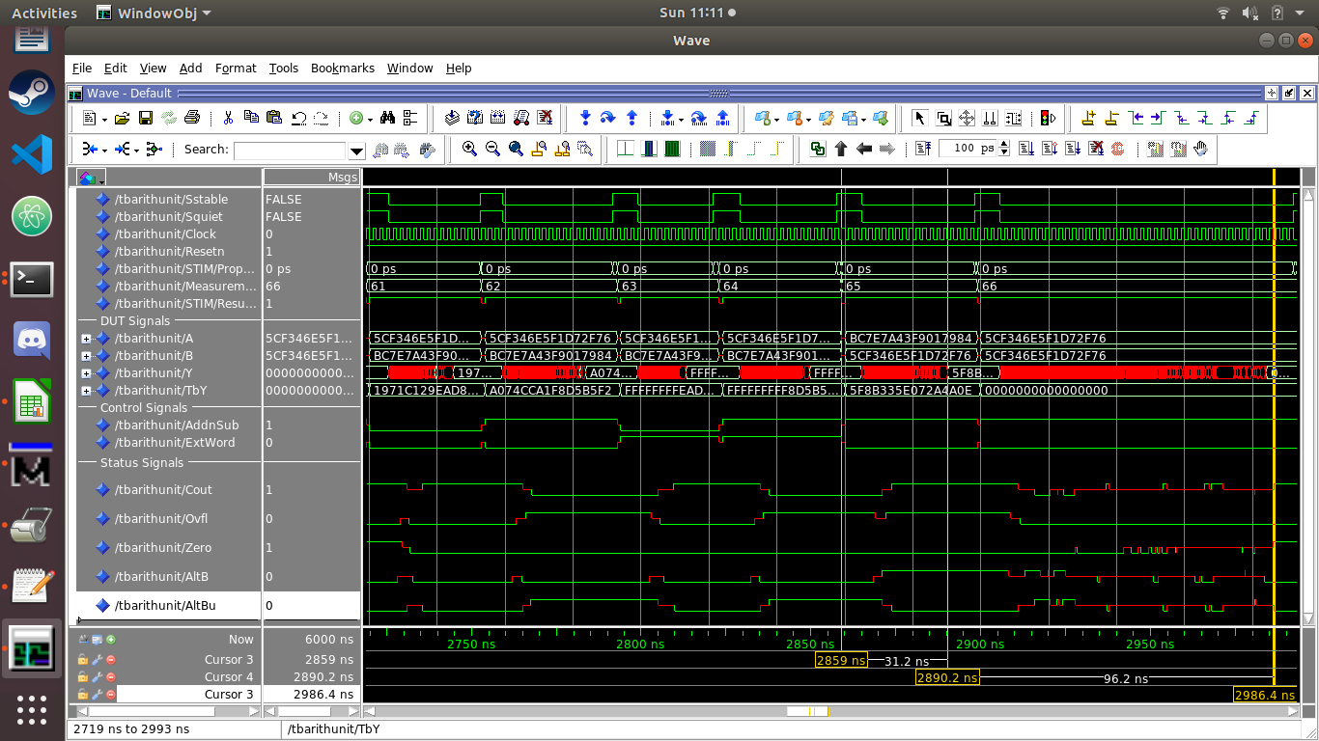

Some of the propagation delays are shown above. Times range from 29.7 ns (measurement 1) to 96.2 (measurement 66) depending on the amount of carry propagations in the ripple adder.

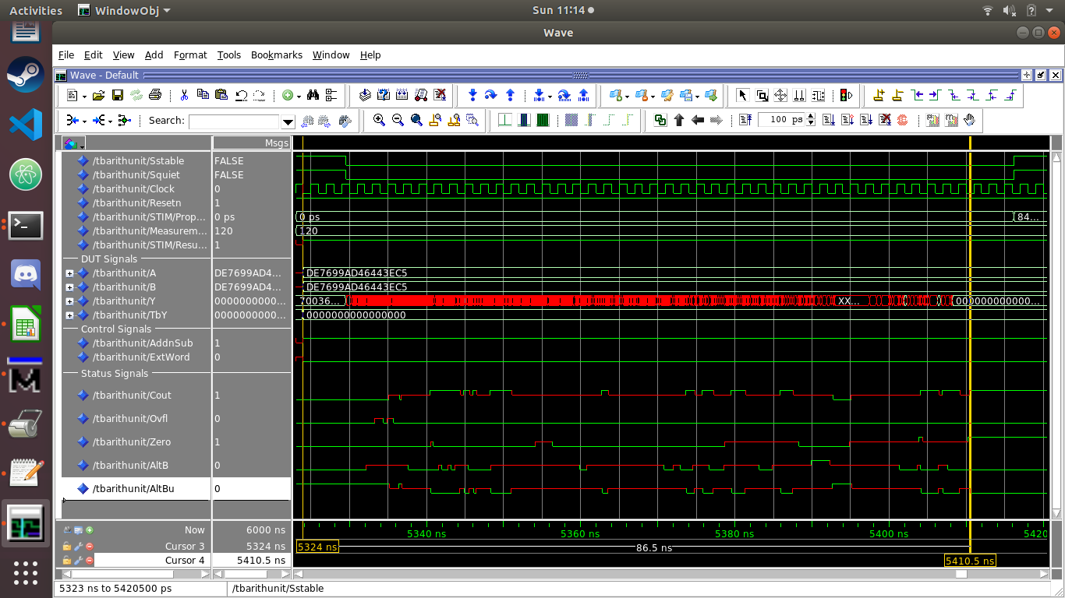

During the simulation, 4 of the 120 measurements returned an error due to an unstable signal. One of these error measurements, #45, is expanded below.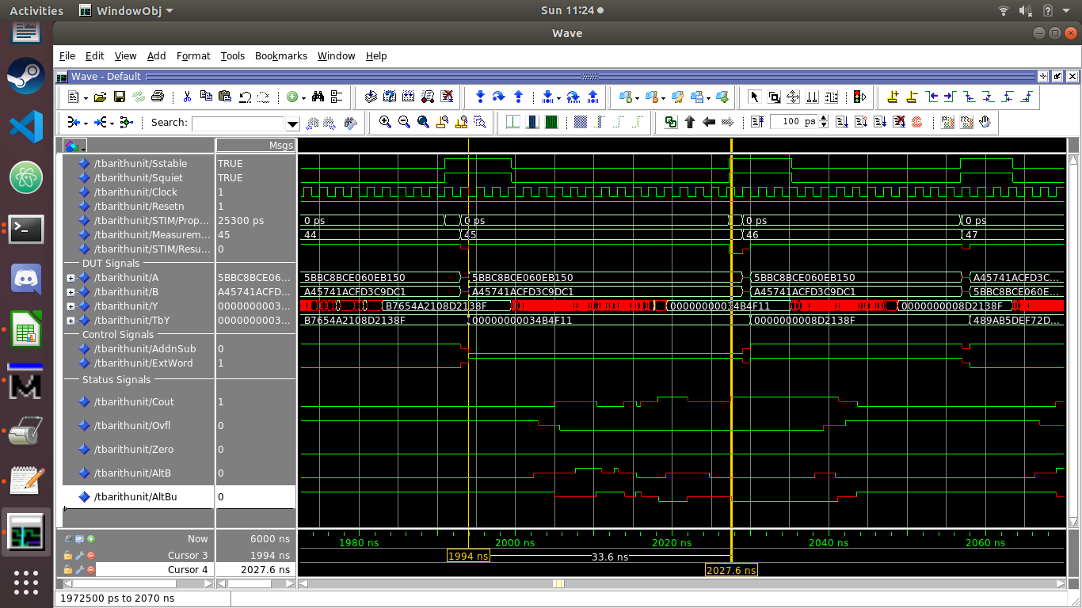

By inspection, all the status signals are correct. We believe this to be a shortcoming of the machine we simulated on. That is, the simulation lagged behind what was expected of the propagation delay. The test checks the value before it becomes stable which causes the error. We also had to increase the simulation runtime from the default in the script due to this anomaly.

## Shift Unit -- Functional Waves

### SLL32

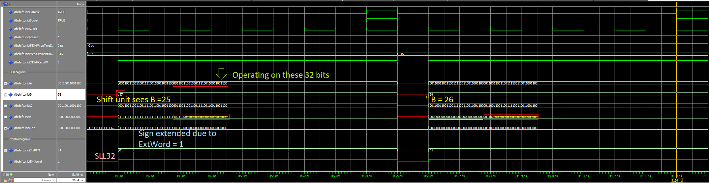

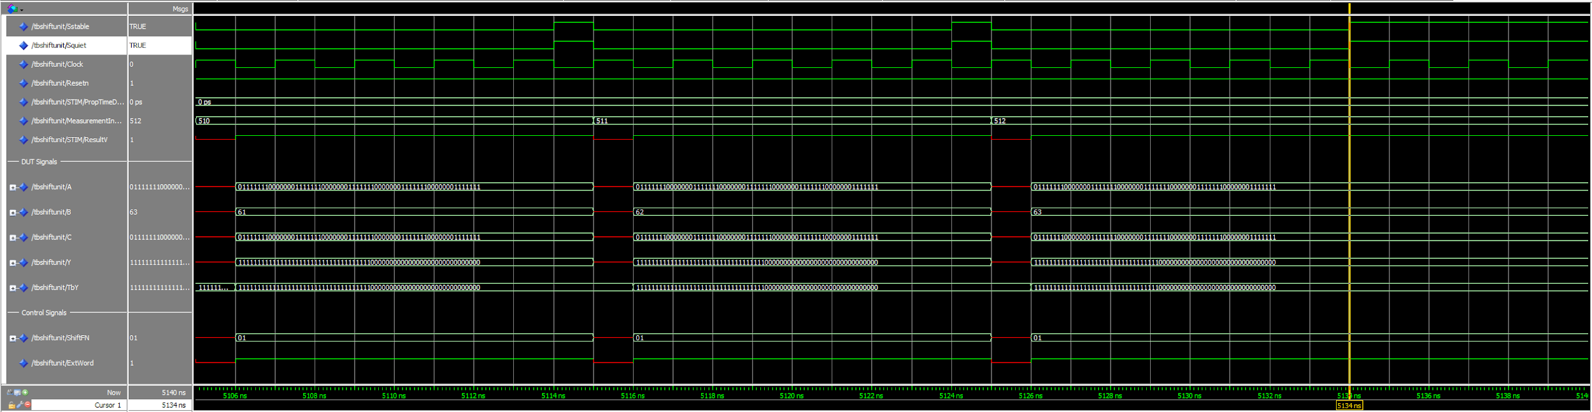

Description:

Waveforms show the results of a functional simulation of a test bench set to test a 32-bit logical shift left [ShiftFN = 01, ExtWord = 1]. This configuration takes the least significant 32 bits of operand A (red outline) and performs a logical shift left in a 32-bit context (yellow strike-out), sign-extending to 64 bits at the output (blue underline). Since the maximum shift amount in this context is 31, values of B at 32 and above are truncated to the least significant 5 bits. The shift value 57 is equivalent to 25 to the hardware, 58 to 26, etc.

### SLL64

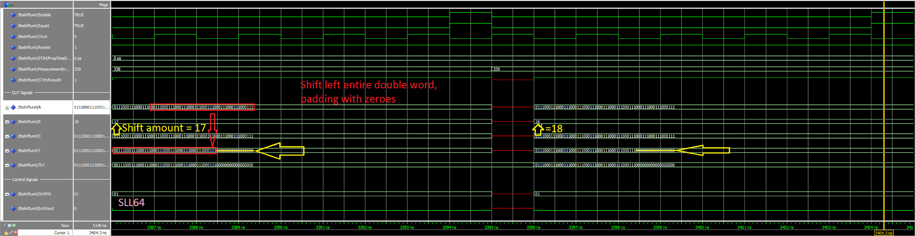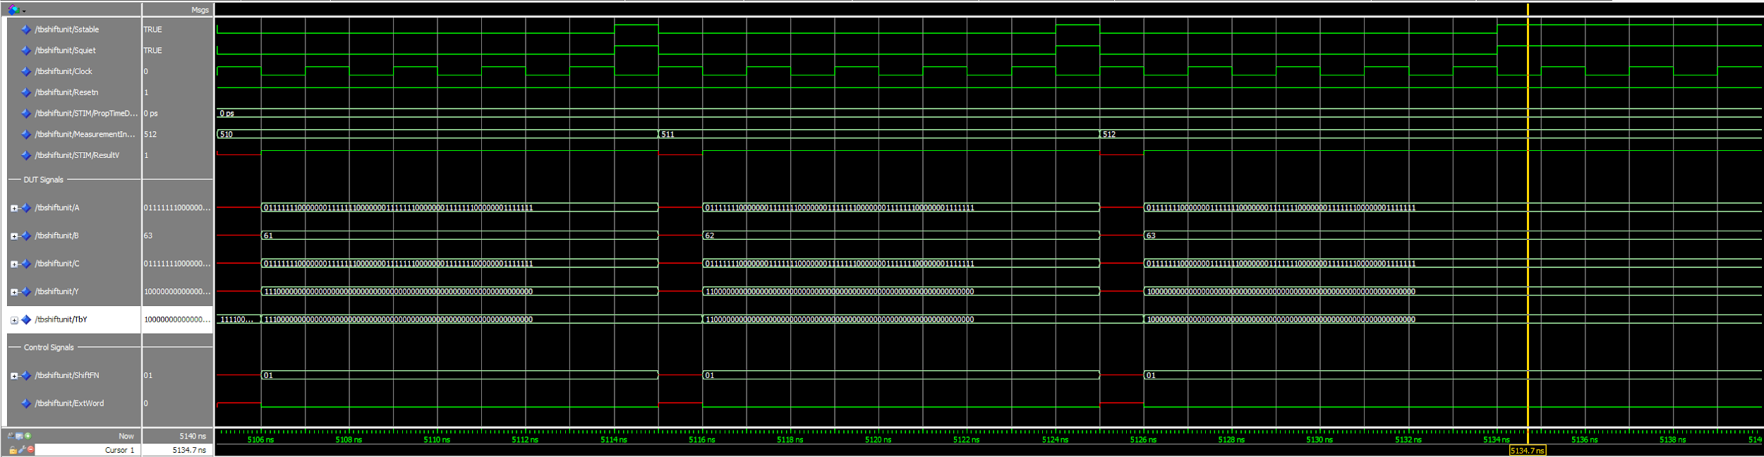

Description:

Results of a functional simulation of a 64-bit logical shift left [ShiftFN = 01, ExtWord = 0]. The bits of operand A (red) are shifted left by the shift amount B (yellow). The shift amount can range from 0 to 63, i.e. the 6 least significant bits of B.

### SRL32

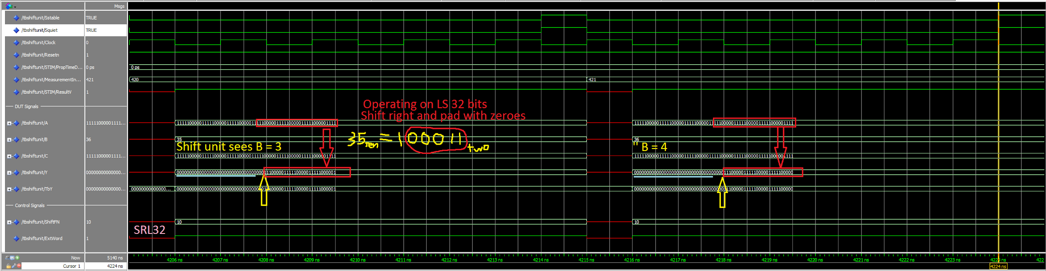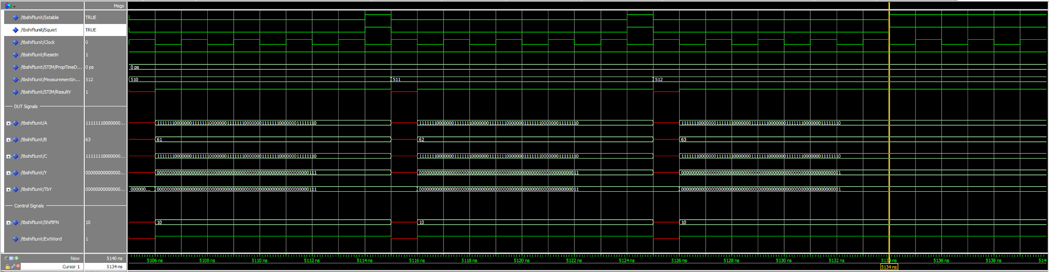

Description:

Results of a functional simulation of a 32-bit logical shift right [ShiftFN = 10, ExtWord = 1]. The upper waveform demonstrates how values of B > 31 are handled. The shift amount is set to the 5 least significant bits of B, thus 35 is equivalent to 3, and 35 to 4.

### SRL64

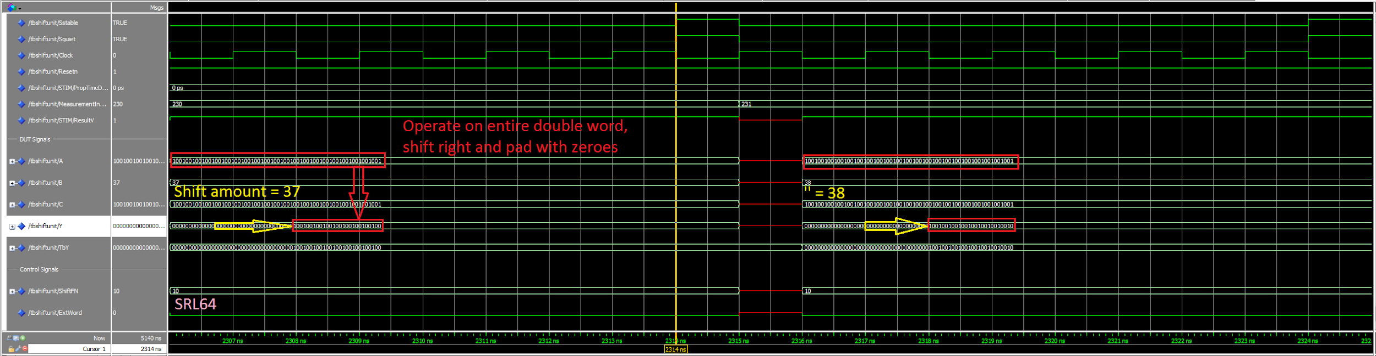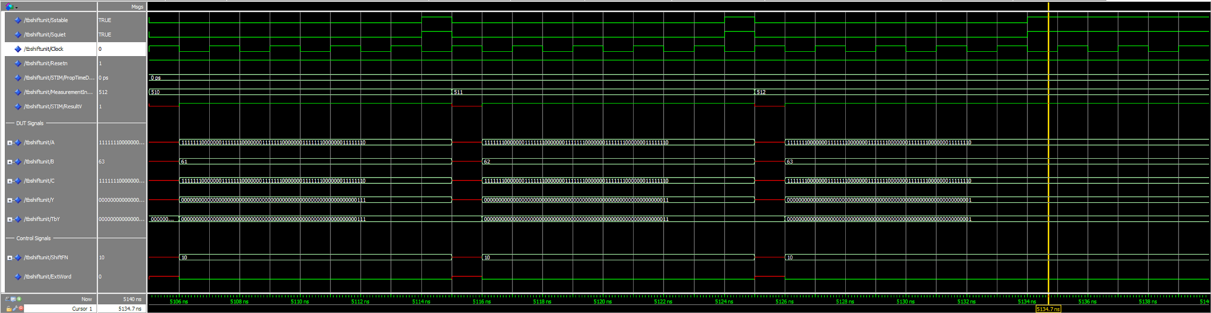

Description:

Results of a functional simulation of a 64-bit logical shift right [ShiftFN = 10, ExtWord = 0]. Operand A is shifted right by the shift amount B and padded with zeros on the left.

### SRA32

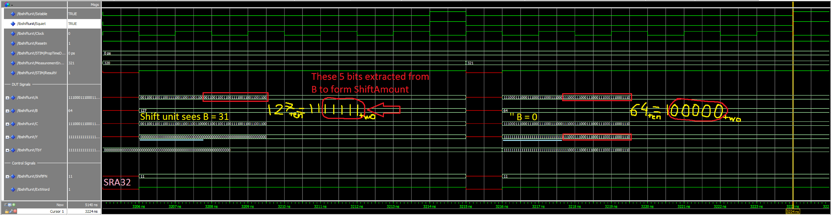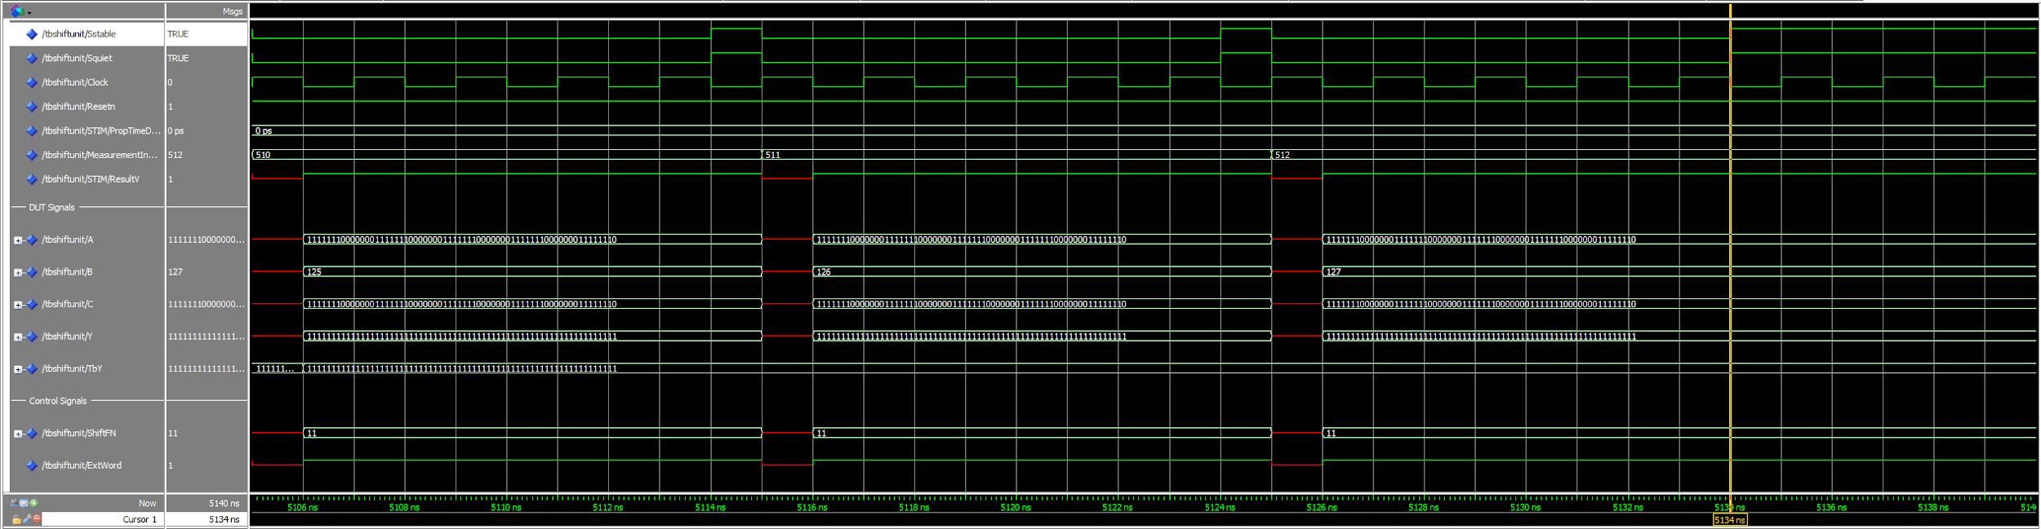

Description:

Results of a functional simulation of a 32-bit arithmetic shift right [ShiftFN = 11, ExtWord = 1]. The shift amount 127 is equivalent to 31 in this context, and 64 equivalent to 0. The least significant 32 bits are shifted to the right and padded with the sign bit of the 32-bit word, i.e. A[31], then further sign extended to 64 bits at the output.

### SRA64

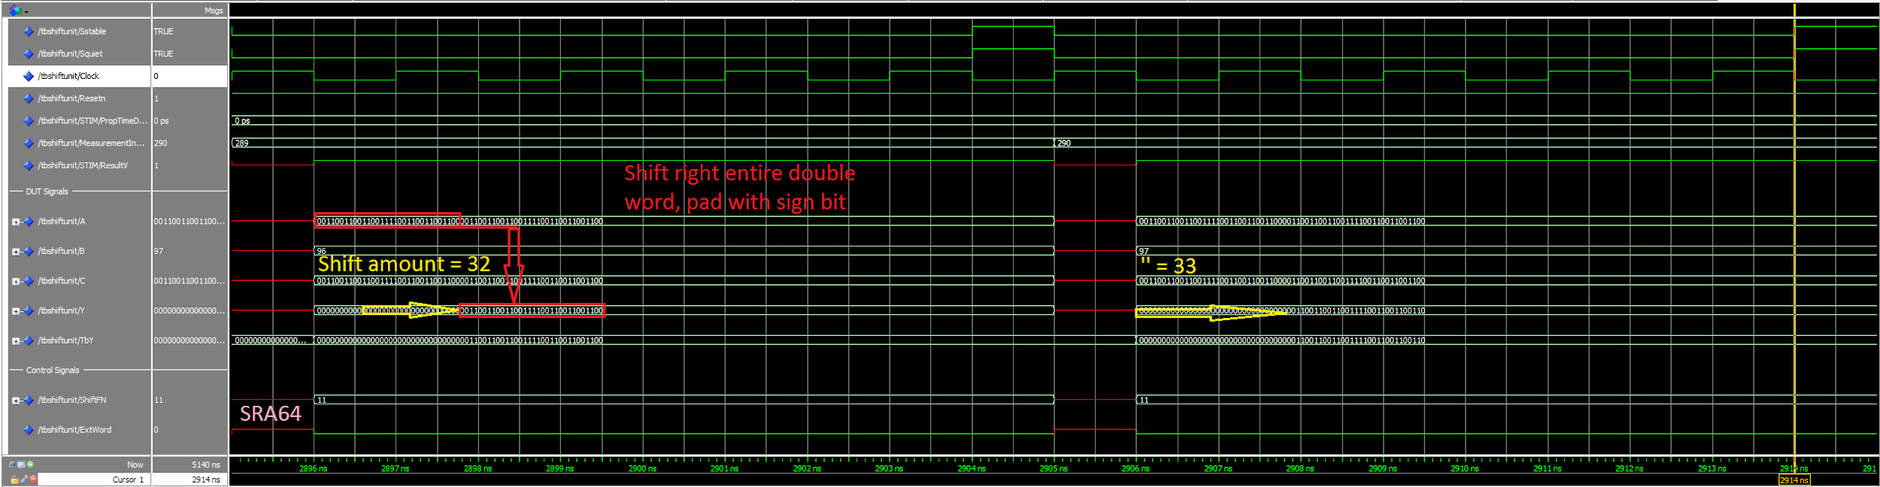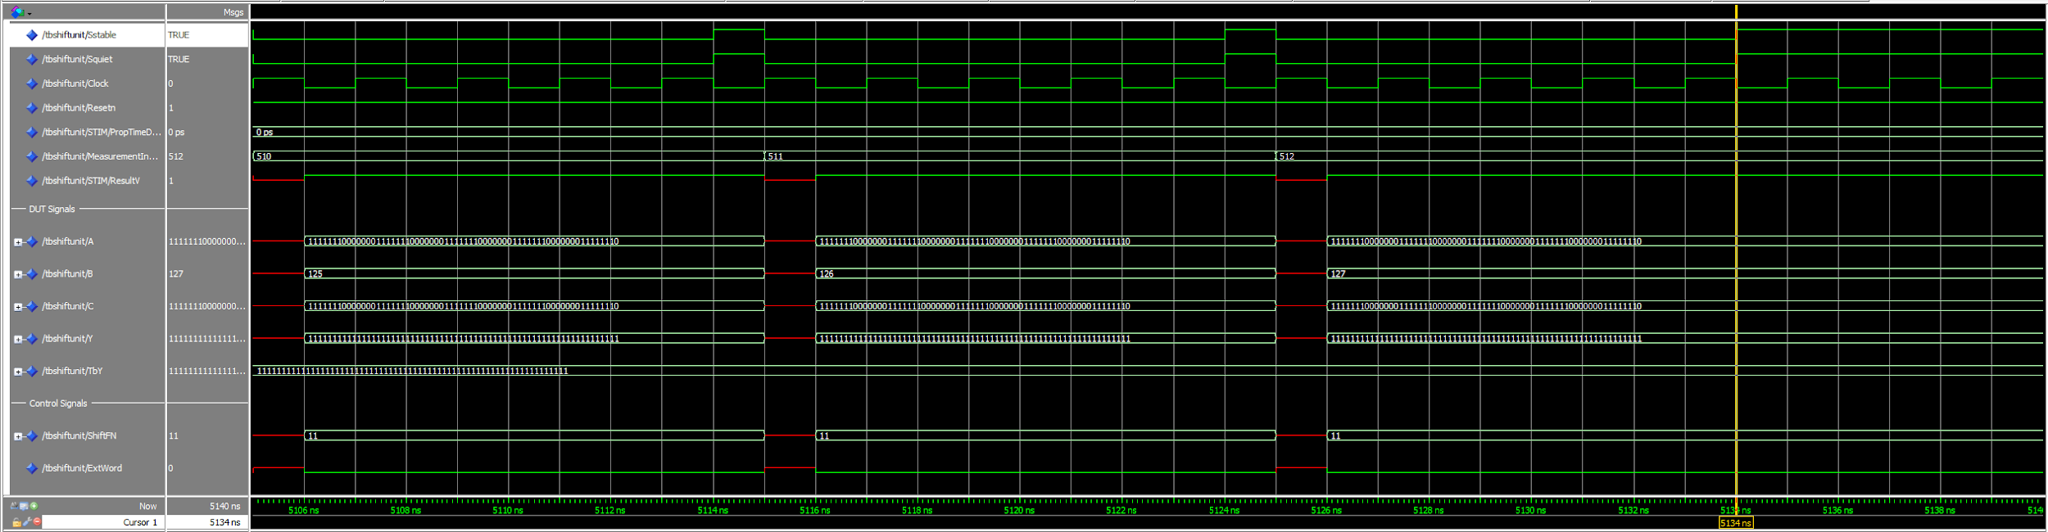

Description:

Results of a functional simulation of a 64-bit arithmetic shift right [ShiftFN = 11, ExtWord = 0]. The entire word is shifted right by the shift unit, while padded on the left by the sign bit: A[63].

## Shift Unit -- Timing Waves

### SLL32

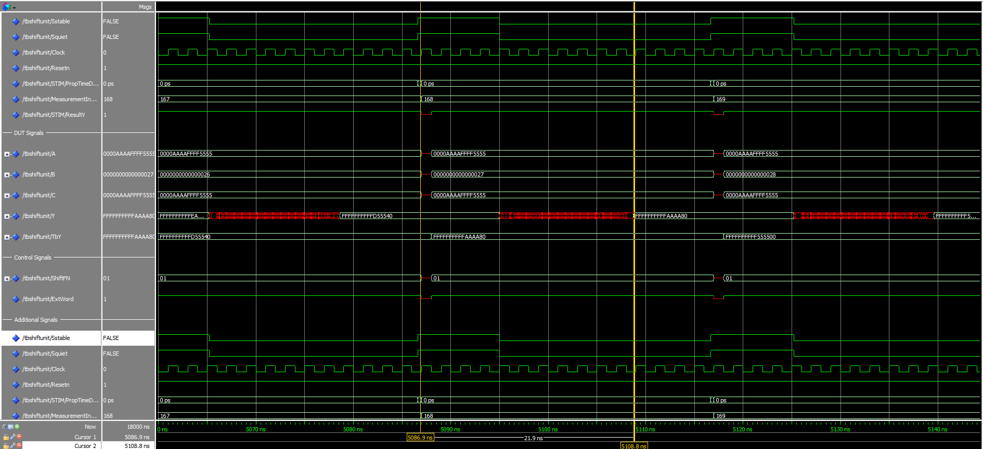

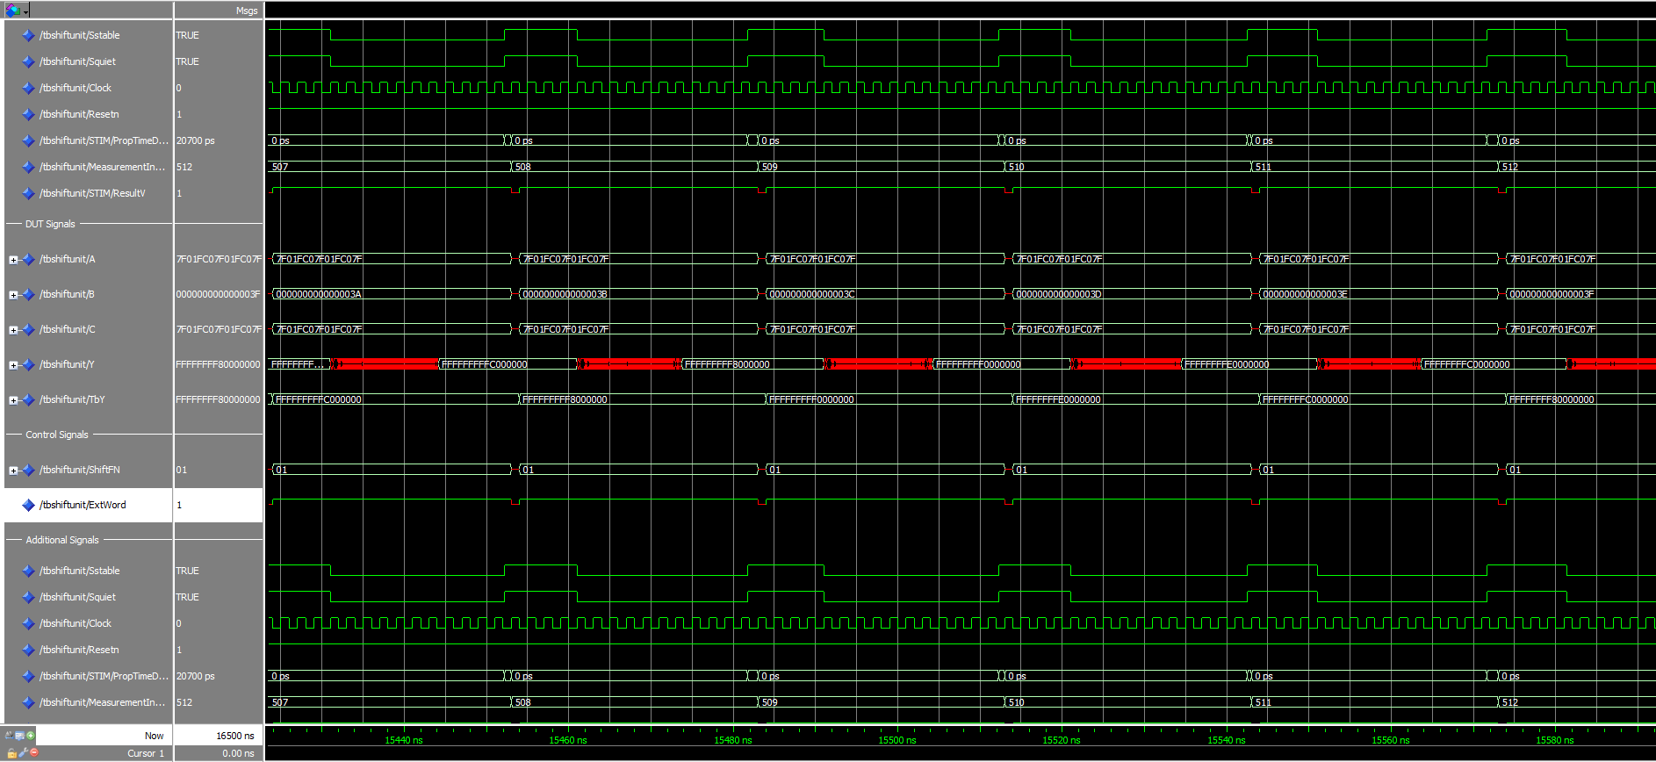

Description:

Waveforms show the results of a functional simulation of a test bench set to test a 32-bit logical shift left [ShiftFN = 01, ExtWord = 1]. The cursors are shown at 5086.9 ns and 5108.8 ns, which show the propagation delay to be 21.9 ns. To compare with the output waves Y and TbY, some delays can be seen with the same amount of time. Therefore, the results are matched as expected by inspection.

### SLL64

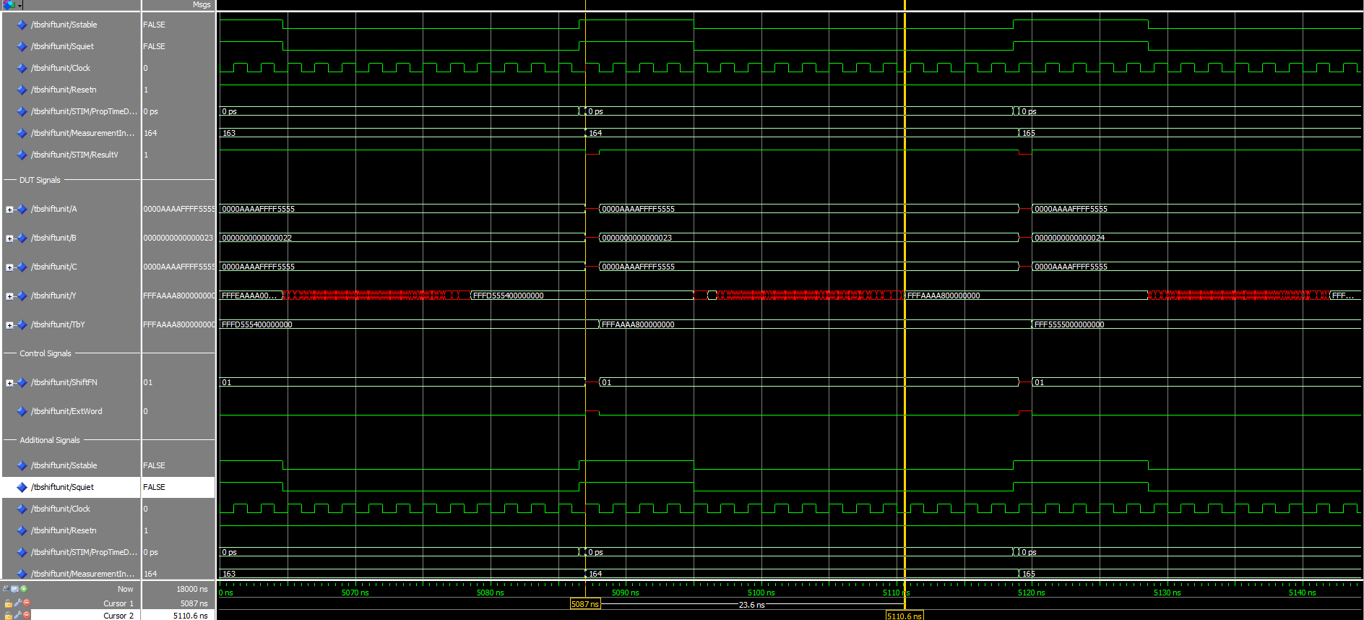

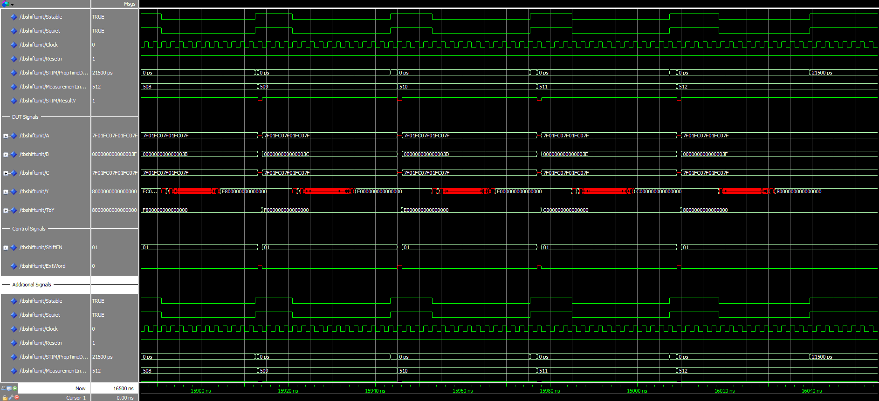

Description:

Waveforms show the results of a functional simulation of a 64-bit logical shift left [ShiftFN = 01, ExtWord = 0]. The propagation delay is 23.6 ns, which is a reasonable result.

### SRL32

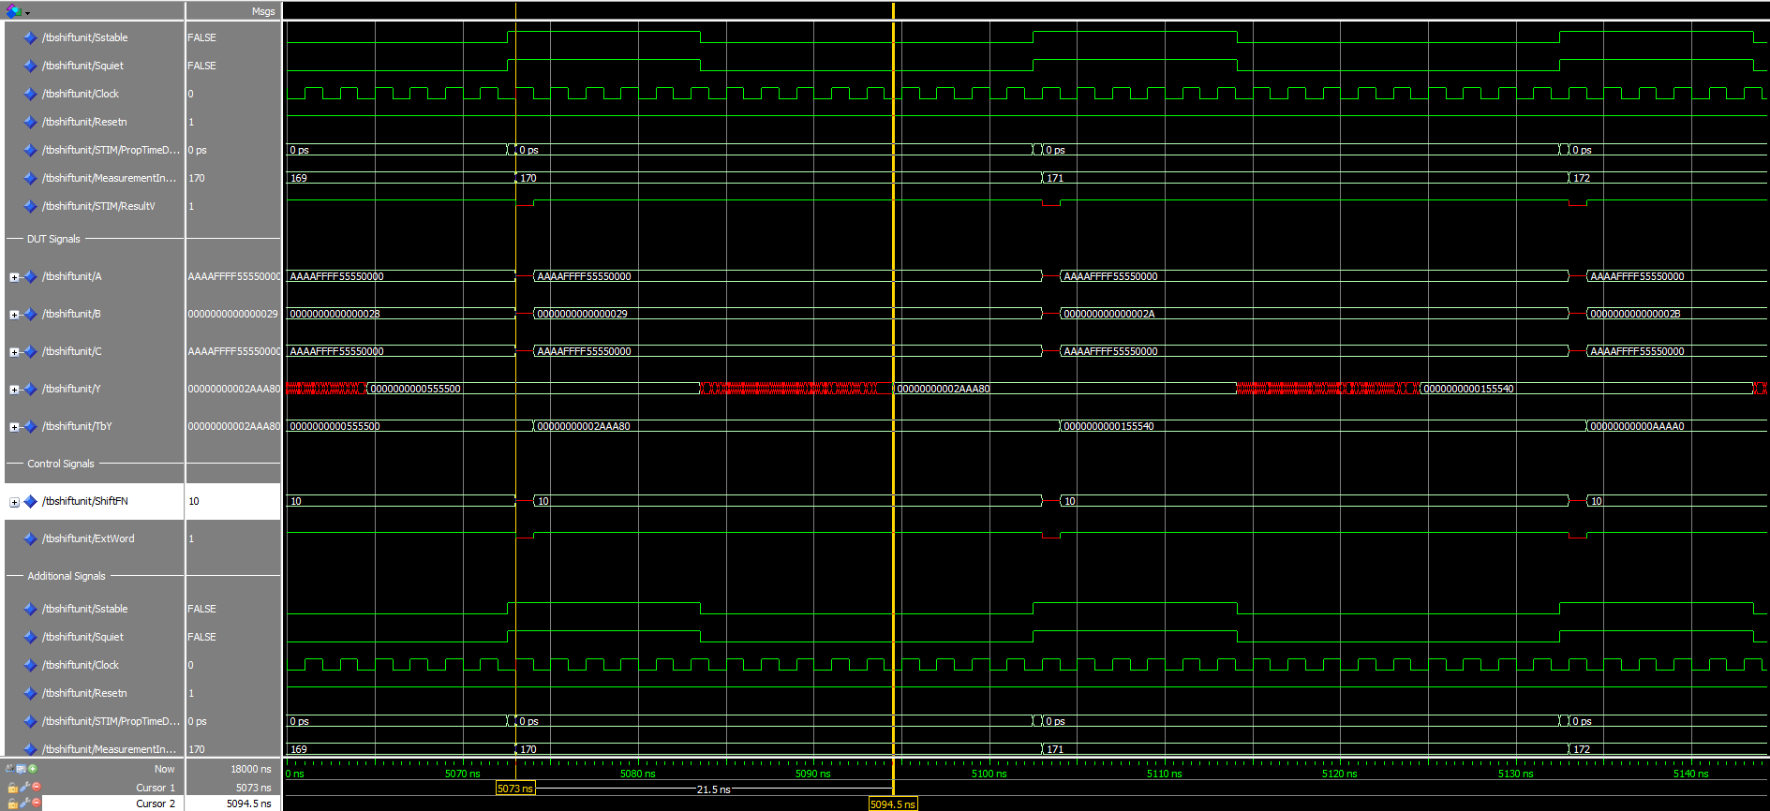

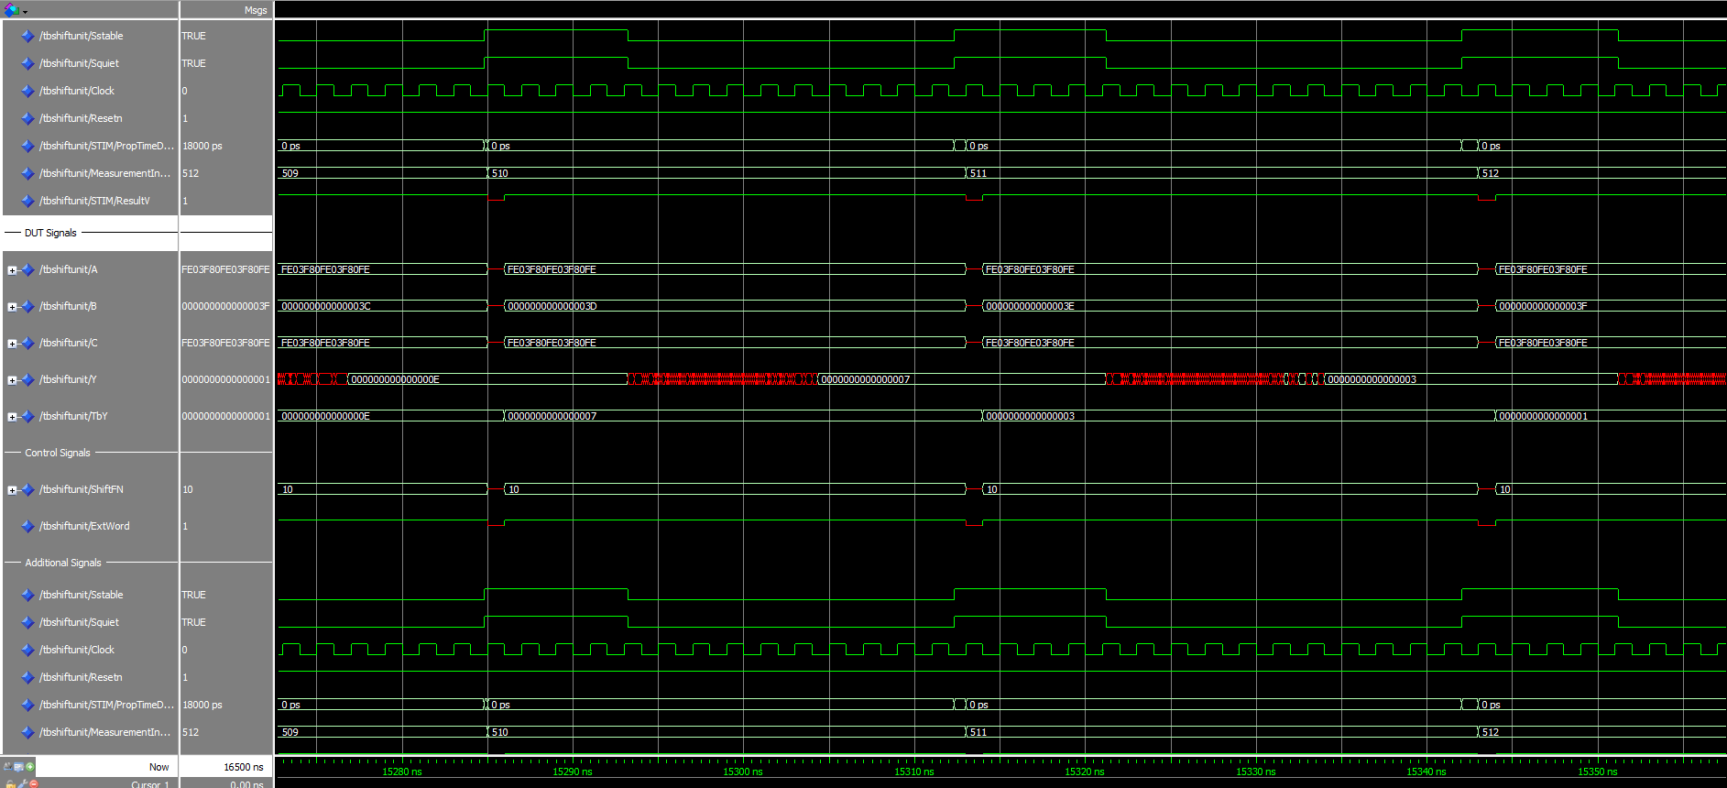

Description:

Waveforms show the results of a functional simulation of a test bench set to test a 32-bit logical shift right [ShiftFN = 10, ExtWord = 1]. The sampled propagation delay is 21.5 ns and other measurements remain near to this value.

### SRL64

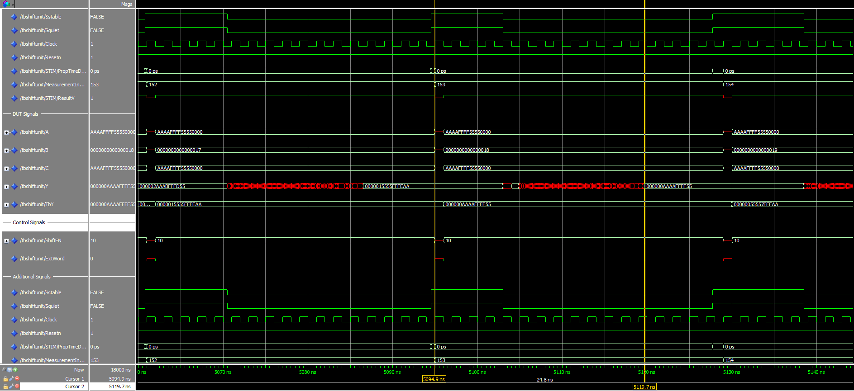

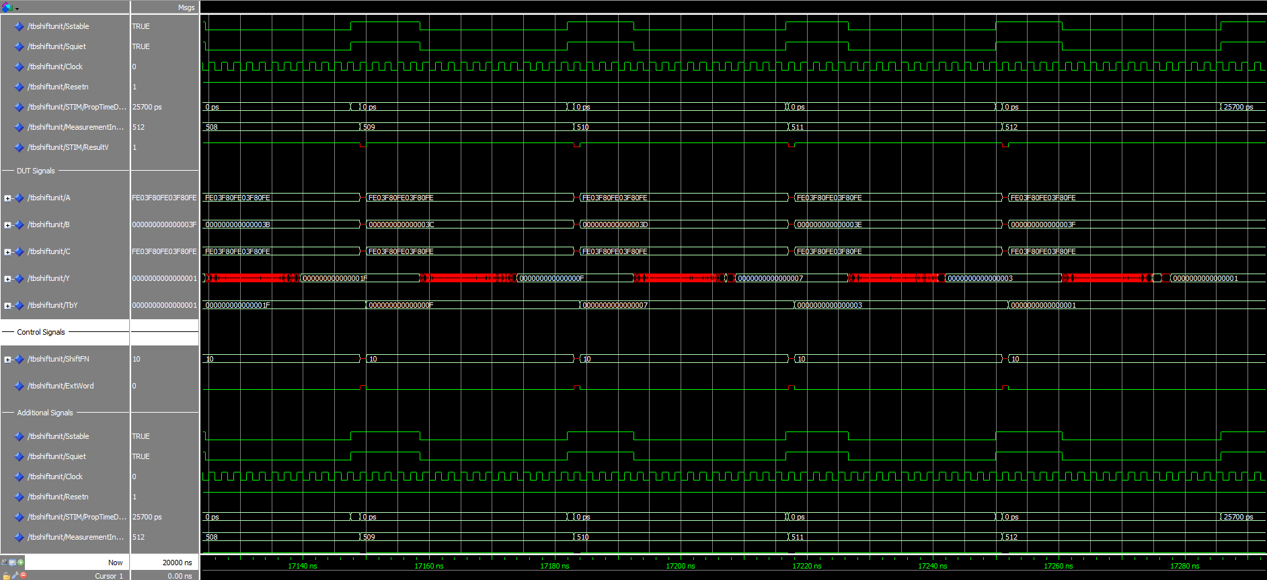

Description:

SRL64 has the highest propagation delay out of all the shifters of $t_{pd}=24.8 ns.$ Here the bits of A are being shifted to the right logically, [ShiftFN = 10, ExtWord = 0].

### SRA32

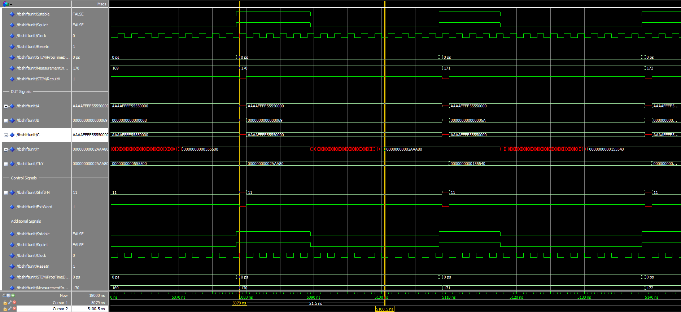

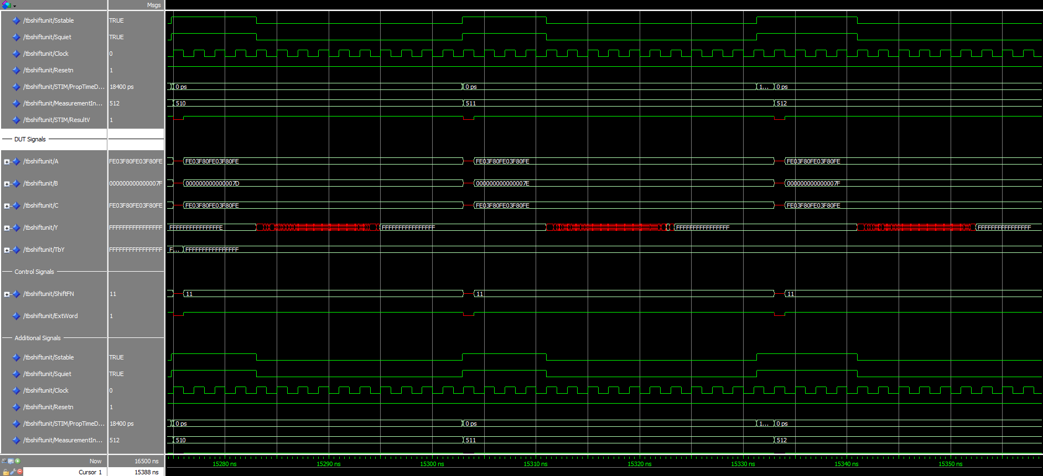

Description:

Waveforms show the results of a functional simulation of a test bench set to test a 32-bit rotational shift right [ShiftFN = 11, ExtWord = 1]. The propagation delay is 21.5 ns.

### SRA64

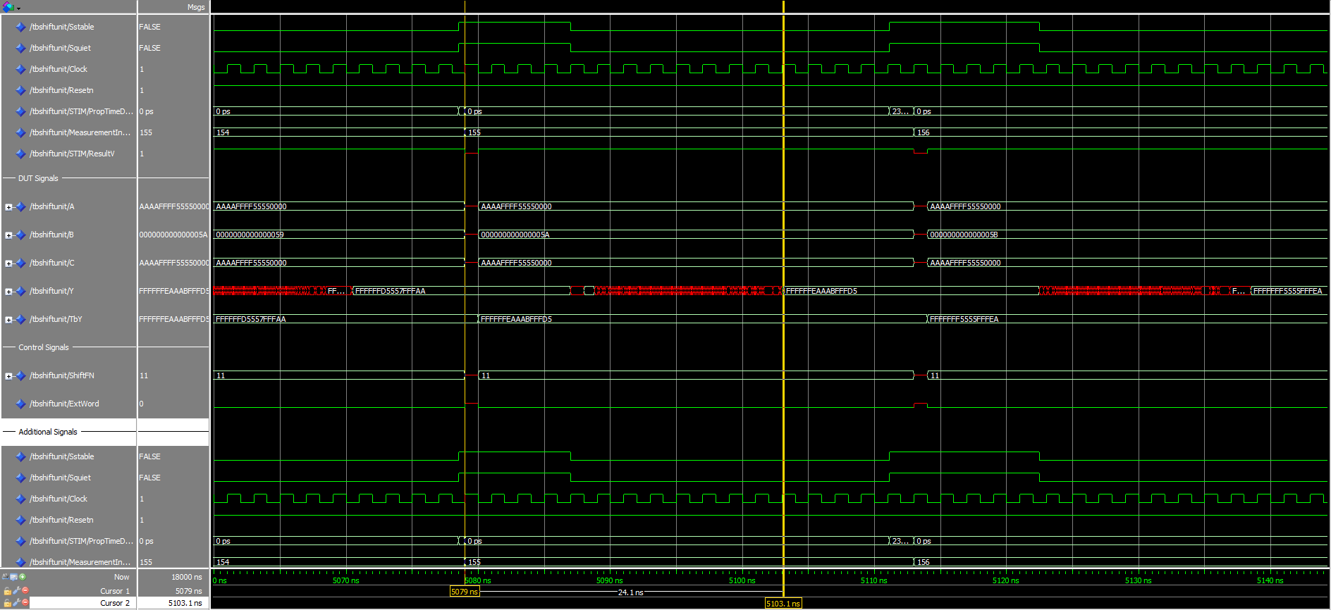

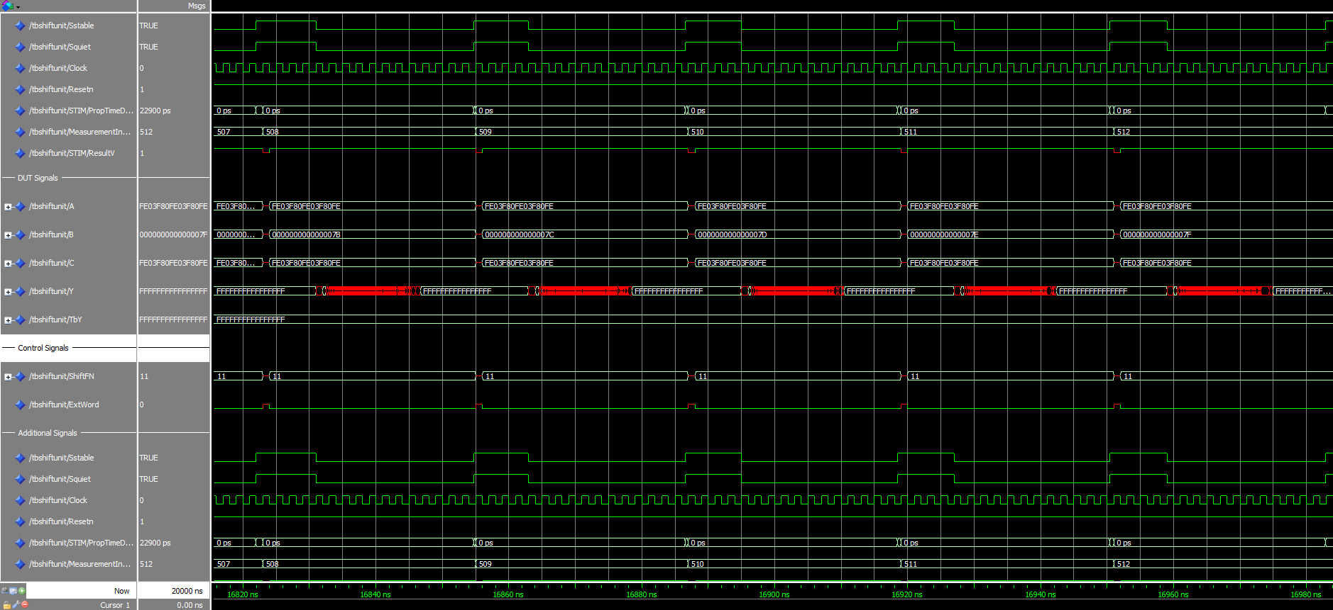

Description:

Waveforms show the results of a functional simulation of a test bench set to test a 64 -bit rotational shift right [ShiftFN = 11, ExtWord = 0]. The propagation delay is 24.1 ns.

## Execution Unit -- Functional Waves

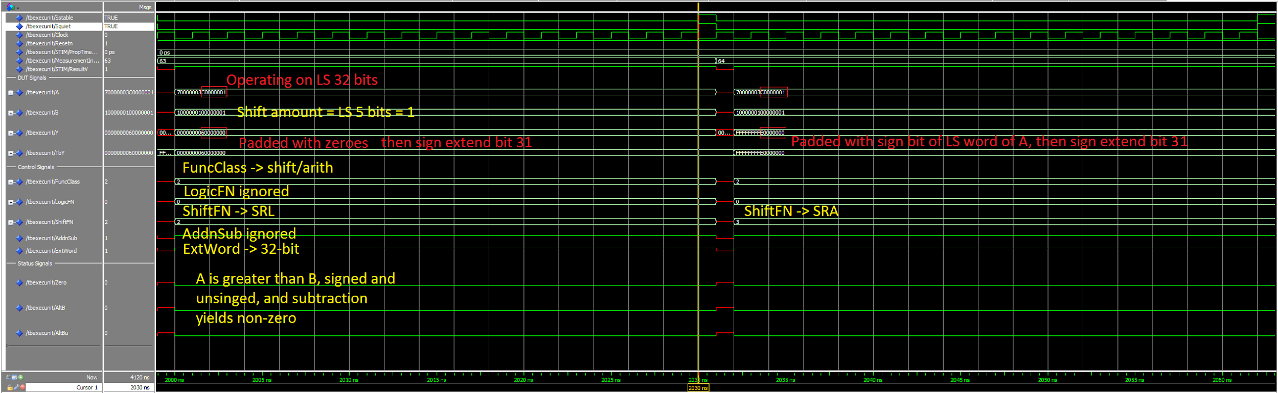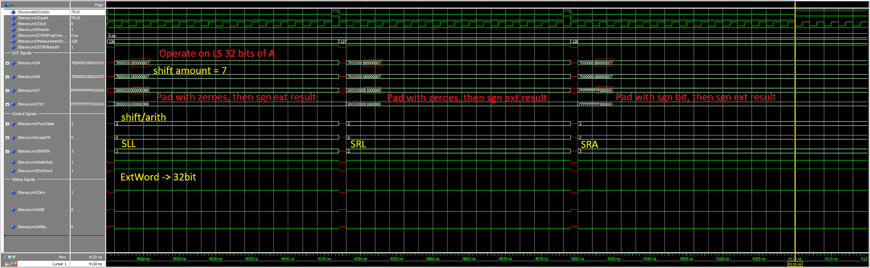

Description:

Results of the functional simulation for the Execution Unit. The control signals determine the type of operation that is represented at the output. FuncClass selects whether the operation is a shift/ arithmetic, logic or comparison operation. LogicFN selects the specific logic operator, if applicable (not in the cases shown above). ShiftFN selects the specific shift operation (all 3 are represented above), AddnSub determine addition or subtraction of the operands and finally ExtWord selects either the 32-bit or 64-bit context. The operations shown above are discussed in a previous section, but it’s worth noting the status signals are being set regardless of the control signals due to the arithmetic computation occurring in parallel with the shifts and logic operations.

## Execution Unit -- Timing Waves

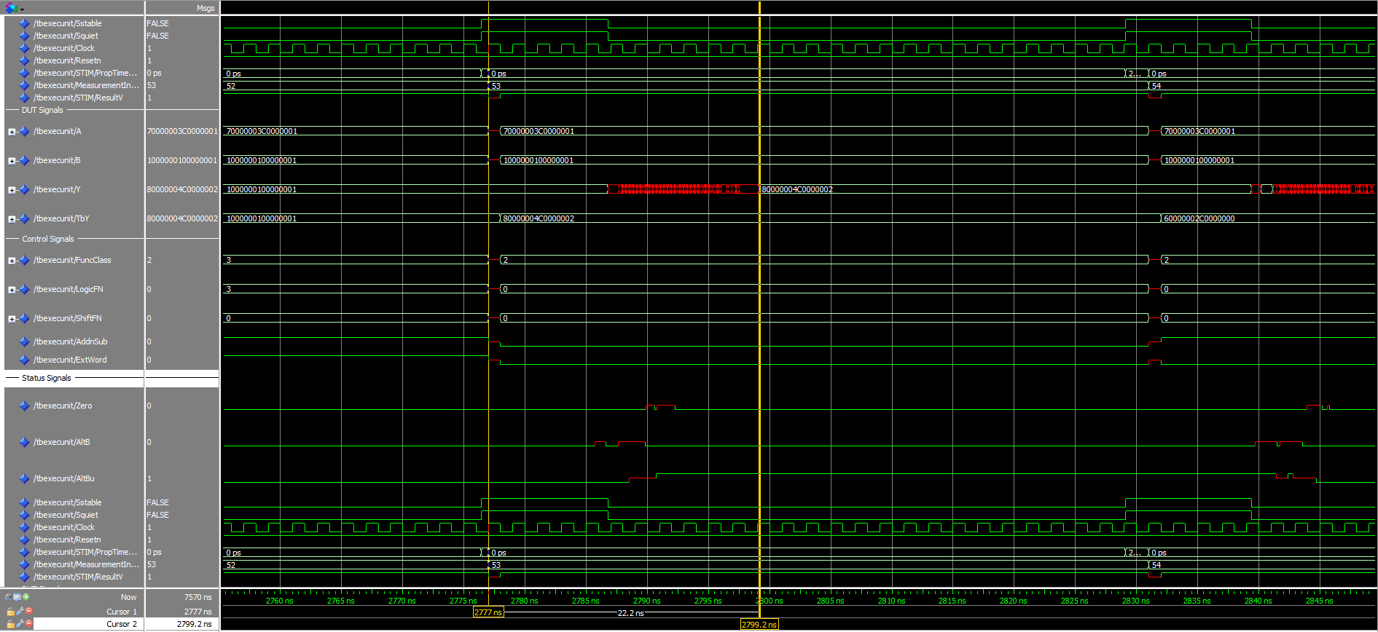

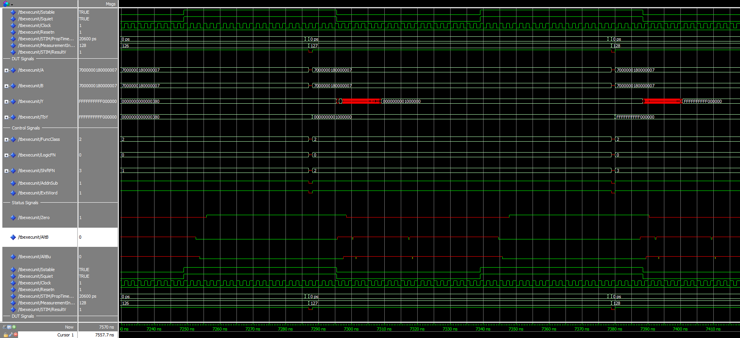

Here you can see the timing waveforms for the Execution Unit. From here we can see the delay of the inputs, A and B, to the point where we get a stable output, Y, which is propagated through the entire system. The propagation delay can be seen as $t_{pd}=22 ns$. Also of note, the large propagation delay on the status signals in measurement 127, due to these signals relying on the ripple carry adder to propagate through.

# Synthesis and Fitting

Arithmetic Unit RTL Adder Screenshot

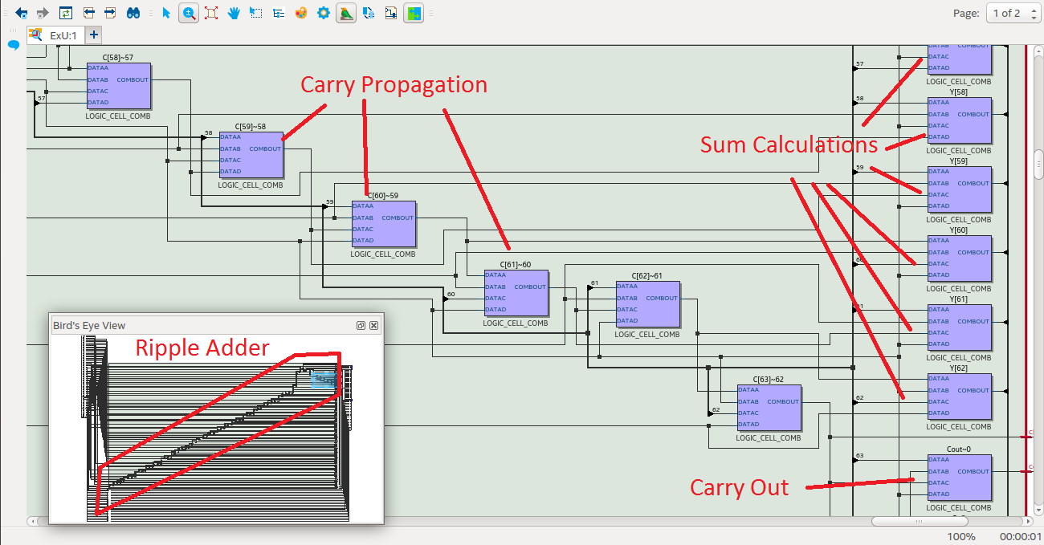

In this screenshot we can see the internals of the arithmetic unit, specifically the Adder, showing the delay propagating through the ripple carry network, sum calculations, and the carry out.

Arithmetic Unit RTL Top Level Screenshot

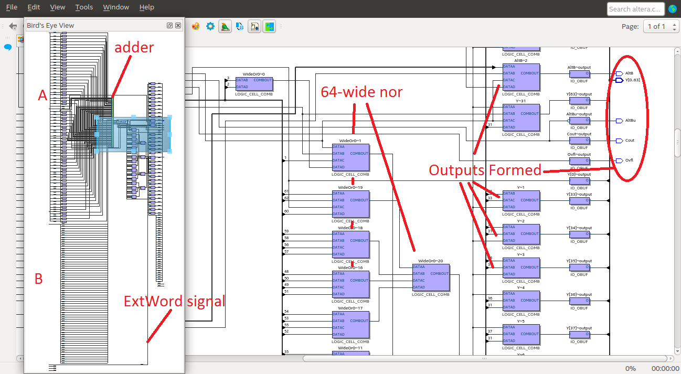

Shown above is the top level of the RTL architecture of the Arithmetic Unit, showing the outputs, the 64-bit-wide NOR gate which generates the “Zero” status signal, and the adder circuit.

Logic Unit RTL Screenshot

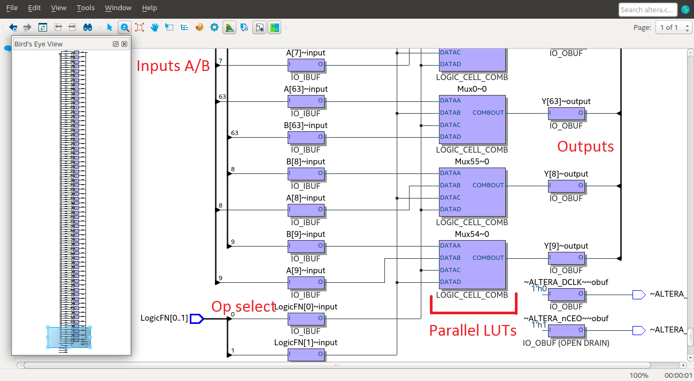

The top level of the Logic Unit, the architecture RTL, shows the outputs of the Logic Unit, the parallel LUTs encoding each of the bitwise logical operations and the operation-selecting control signal “LogicFN.”

Shift Left Logical 64 bit RTL Screenshot

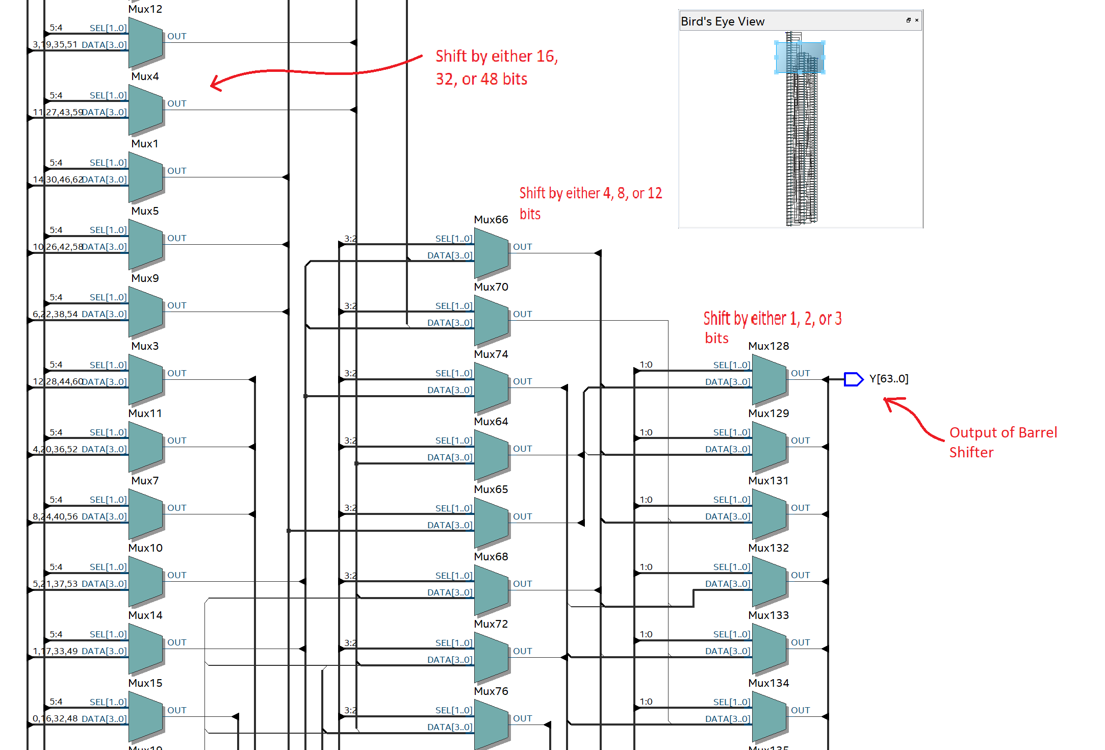

The first column of MUXes is controlled by ShiftCount(5,4) and can shift the input by either 16, or 32, or 48 bits to the left. The second column of MUXes is controlled by ShiftCount(3,2) and can shift the input by either 4, or 8, or 12 bits to the left. The third column of MUXes is controlled by ShiftCount(1,0) and can shift the input by either 1, or 2, or 3 bits to the left.

Shift Right Arithmetic 64 bit RTL Screenshot

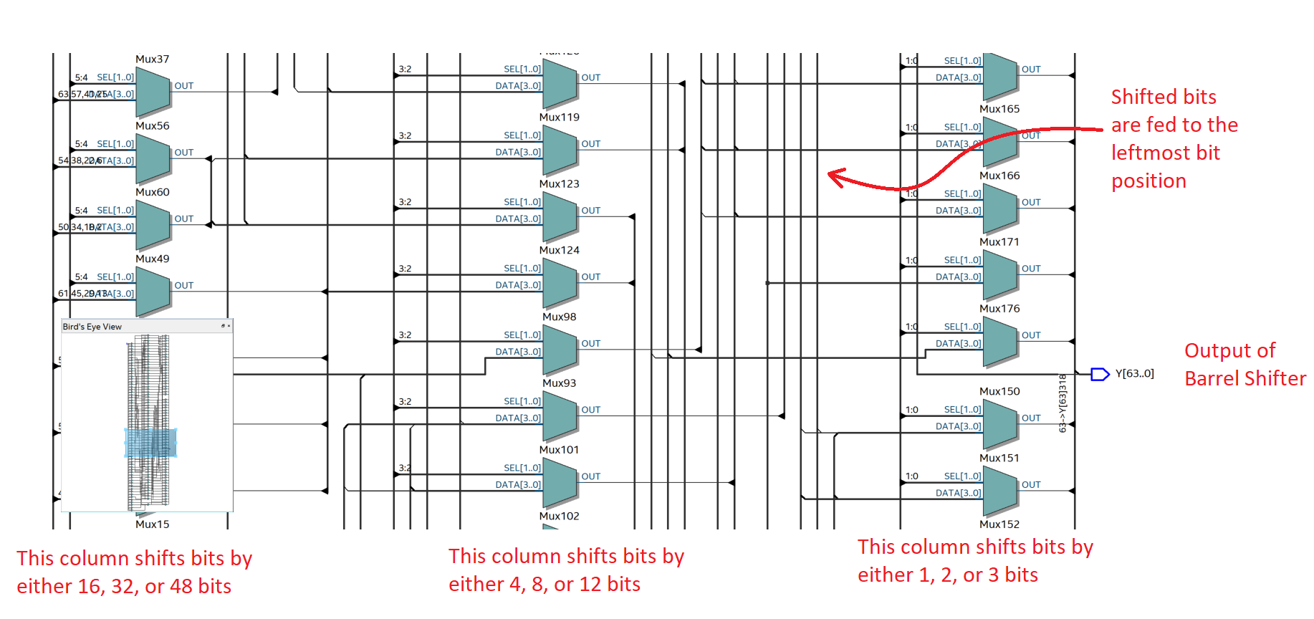

The first column of MUXes is controlled by ShiftCount(5,4) and can shift the input by either 16, or 32, or 48 bits to the right. The second column of MUXes is controlled by ShiftCount(3,2) and can shift the input by either 4, or 8, or 12 bits to the right. The third column of MUXes is controlled by ShiftCount(1,0) and can shift the input by either 1, or 2, or 3 bits to the right. The rightmost bits are being fed up to the leftmost bits when they are shifted as you can see here.

Shift Right Logical 64 bit RTL Screenshot

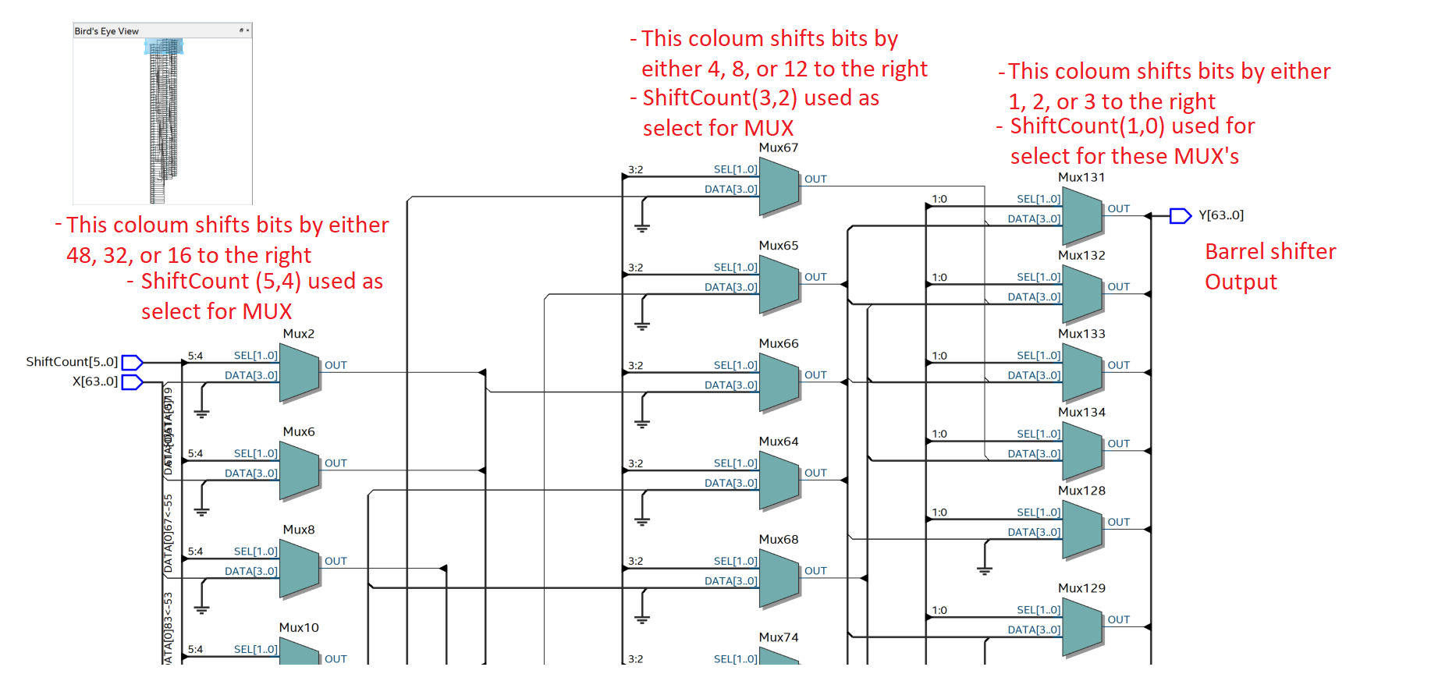

The first column of MUXes is controlled by ShiftCount(5,4) and can shift the input by either 16, or 32, or 48 bits to the right. The second column of MUXes is controlled by ShiftCount(3,2) and can shift the input by either 4, or 8, or 12 bits to the right. The third column of MUXes is controlled by ShiftCount(1,0) and can shift the input by either 1, or 2, or 3 bits to the right.

Shift Unit RTL Screenshot

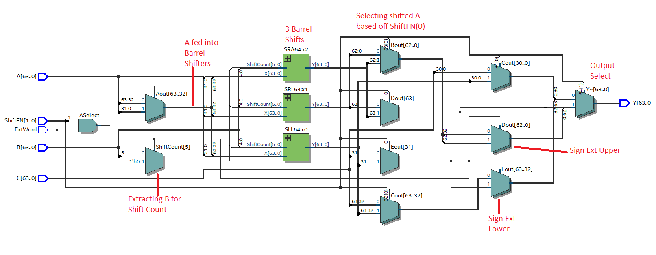

This RTL viewer shows the Input , A, going through the 3 different barrel shifters and the output is selected based on which ShiftFN operation is inputted. The output can also be lower/upper sign extended, based on if ExtWord is a 0 or a 1.

Execution Unit RTL Screenshot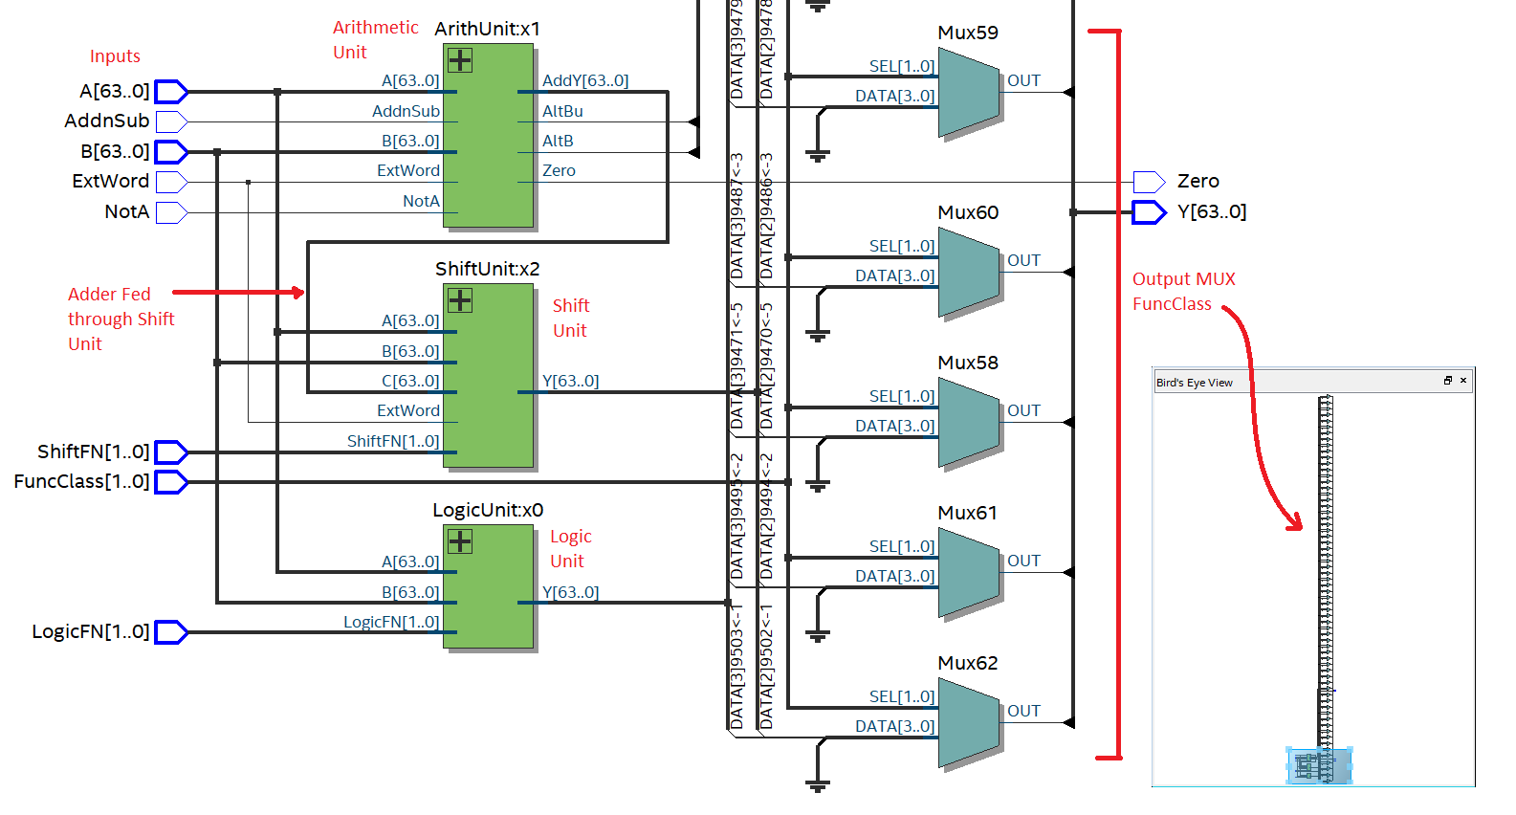

Here we can see how all our units are working together to make the execution unit. The inputs A and B are only fed into the arithmetic unit, which in turn feeds into the shift unit, and then is fed into some MUX’s in order to get the final values.

# Conclusion

We have first made the elemental entities, and made some descriptions which introduced the components of each entity and how they function. The functional simulations were then made to ensure the entities follow their specified behaviour. From the waveforms, we can see that almost all of the waveforms match with the expected results, except Arithmetic Unit -- Timing Waves, which is due to the lagging behind from the expected propagation delay. Notable delays happen whenever the Arithmetic Unit is involved, e.g. the status signals always rely on carry propagation, though these signals are not always needed. As such, in order to improve the Execution Unit, a better alternative to a ripple-carry adder can be employed, such as a Brent-Kung carry network. Finally, the netlist screenshots are collected to show the RTL and post-fit circuits of the entities in detail and some basic descriptions about the circuits are provided.